**CST8912 – Cloud Solution Architecture**

**Graded Lab Activity #8**

1. Apply solutions for ensuring compliance with organizational policies and regulatory requirements. (7)

* Adapt shared responsibility model to ensure safe and secure cloud environment
* Interpret industry standards for handling data in cloud
* Underline laws and regulations for cloud compliance, data privacy, data protection, and cybersecurity
* Identify cloud governance, control measures, and policies to manage data within the cloud

**Introduction:**

Tagging your resources for a cloud environment is a crucial task for IT, especially when managing and deploying for multiple departments and projects. Tags are one of the elementary tasks included in the Cloud Adoption Framework that lets you take the benefit of the cloud resources to their fullest and ensure that you are taking the maximum advantage of the money spent in the cloud.

Tagging is considered one of the fundamental pillars of Cloud Governance to ensure the workloads deployed in the cloud are organized and stay that way for the entire lifecycle of the resources. Tagging the cloud resources opens up the world of possibility for you to leverage other services such as Cloud Policy and Cloud Runbooks to automate various tasks for specific resources and ensure their compliance in an automated fashion.

In this hands-on lab, you will discover what tags are and how you can implement them in your cloud environment to manage and create the identity for your cloud resources and how to assign azure policy

**Purpose of the hands-on-lab that can be simulated for any CSP:**

In this lab you will understand the governance principle for tagging azure resources

1. Task 1: Create and assign tags via the Azure portal
2. Task 2: Enforce tagging via an Azure policy
3. Task 3: Apply tagging via an Azure policy
4. Task4: Configure and test resource locks
5. Task 5: Clean up the resources

**Task 1: Assign tags via the Azure portal**

1. Sign in to the Azure portal - <https://portal.azure.com>.
2. Search for and select Resource groups.

| Setting | Value |
| --- | --- |
| Subscription name | your subscription |
| Resource group name | CST8912 |
| Location | Canada Central |

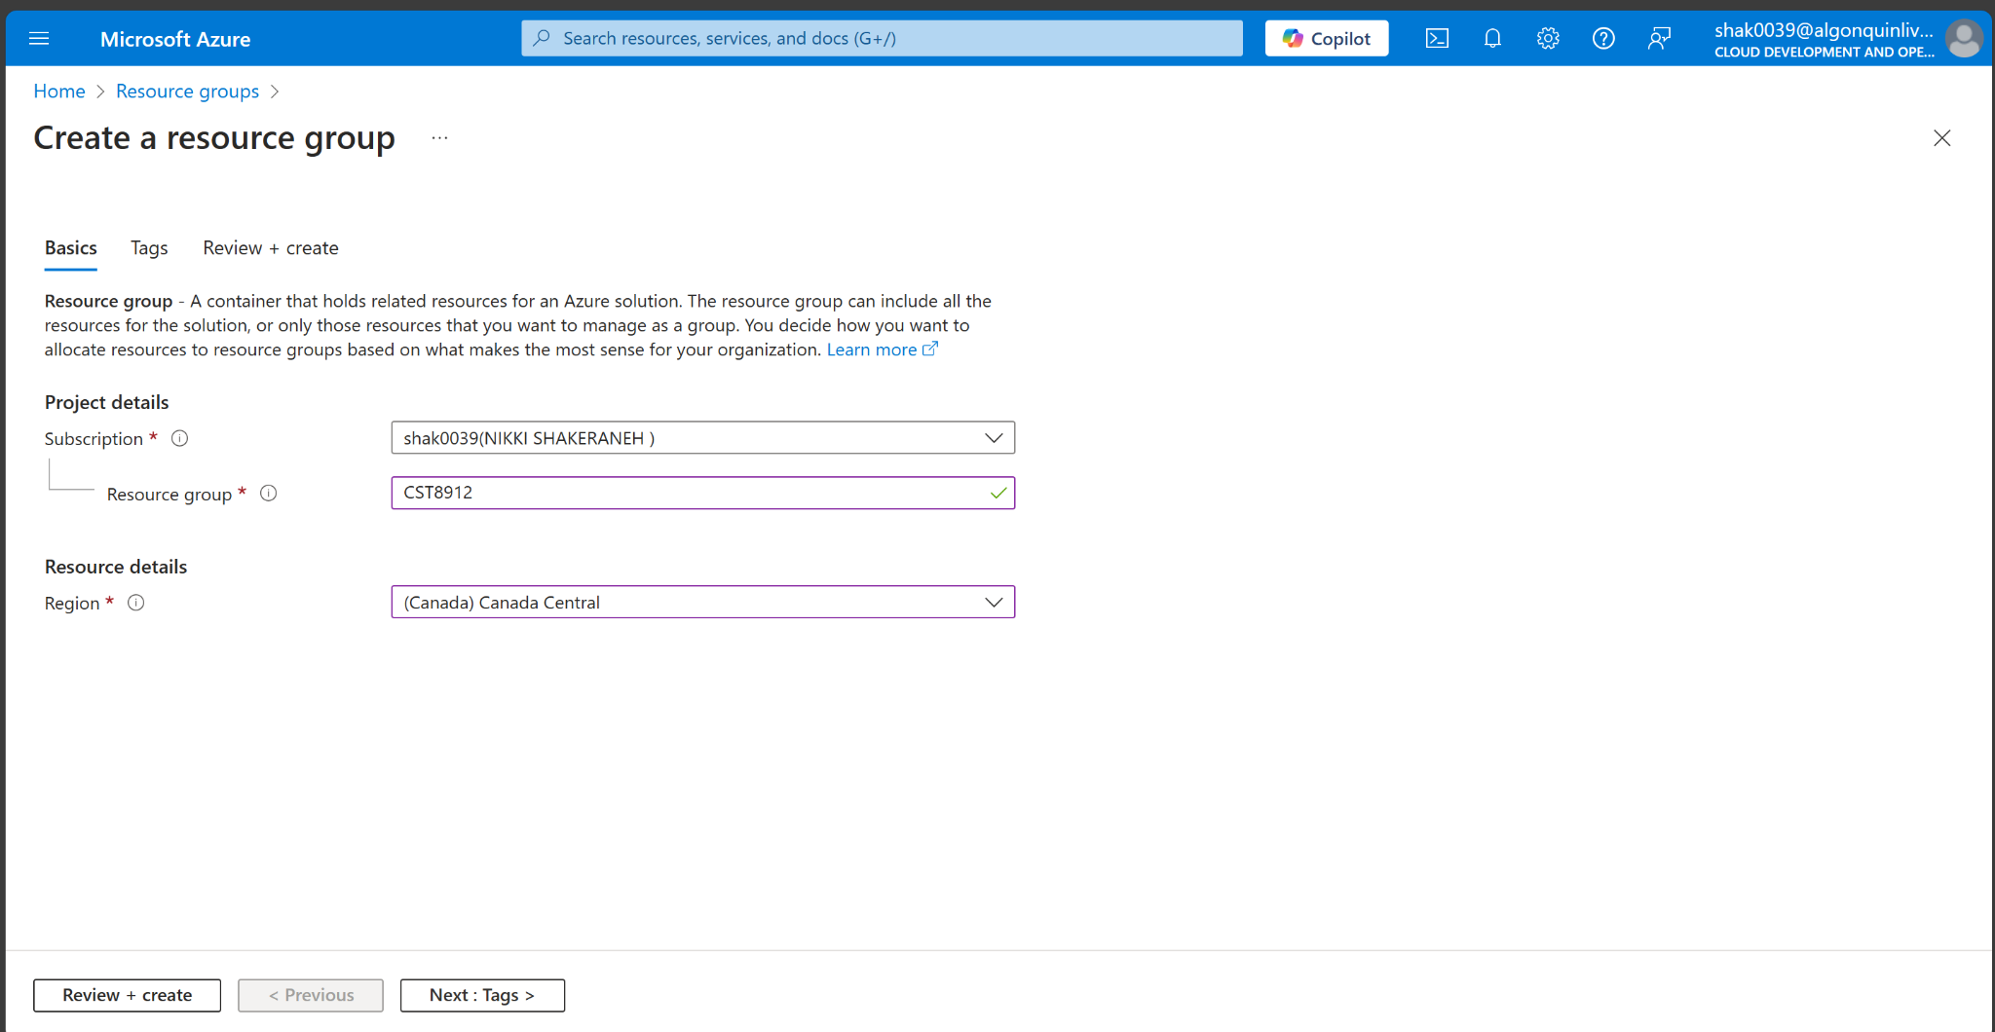

1. From the Resource groups, select + Create.
2. Note
3. Select Next: Tags and create a new tag.

| Setting | Value |
| --- | --- |
| Name | Cost Center |
| Value | 000 |

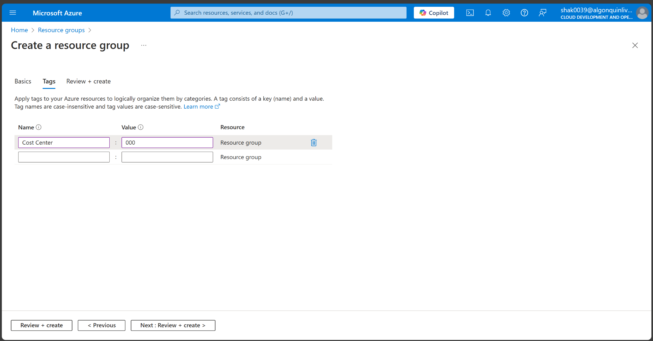

1. Select Review + Create, and then select Create.

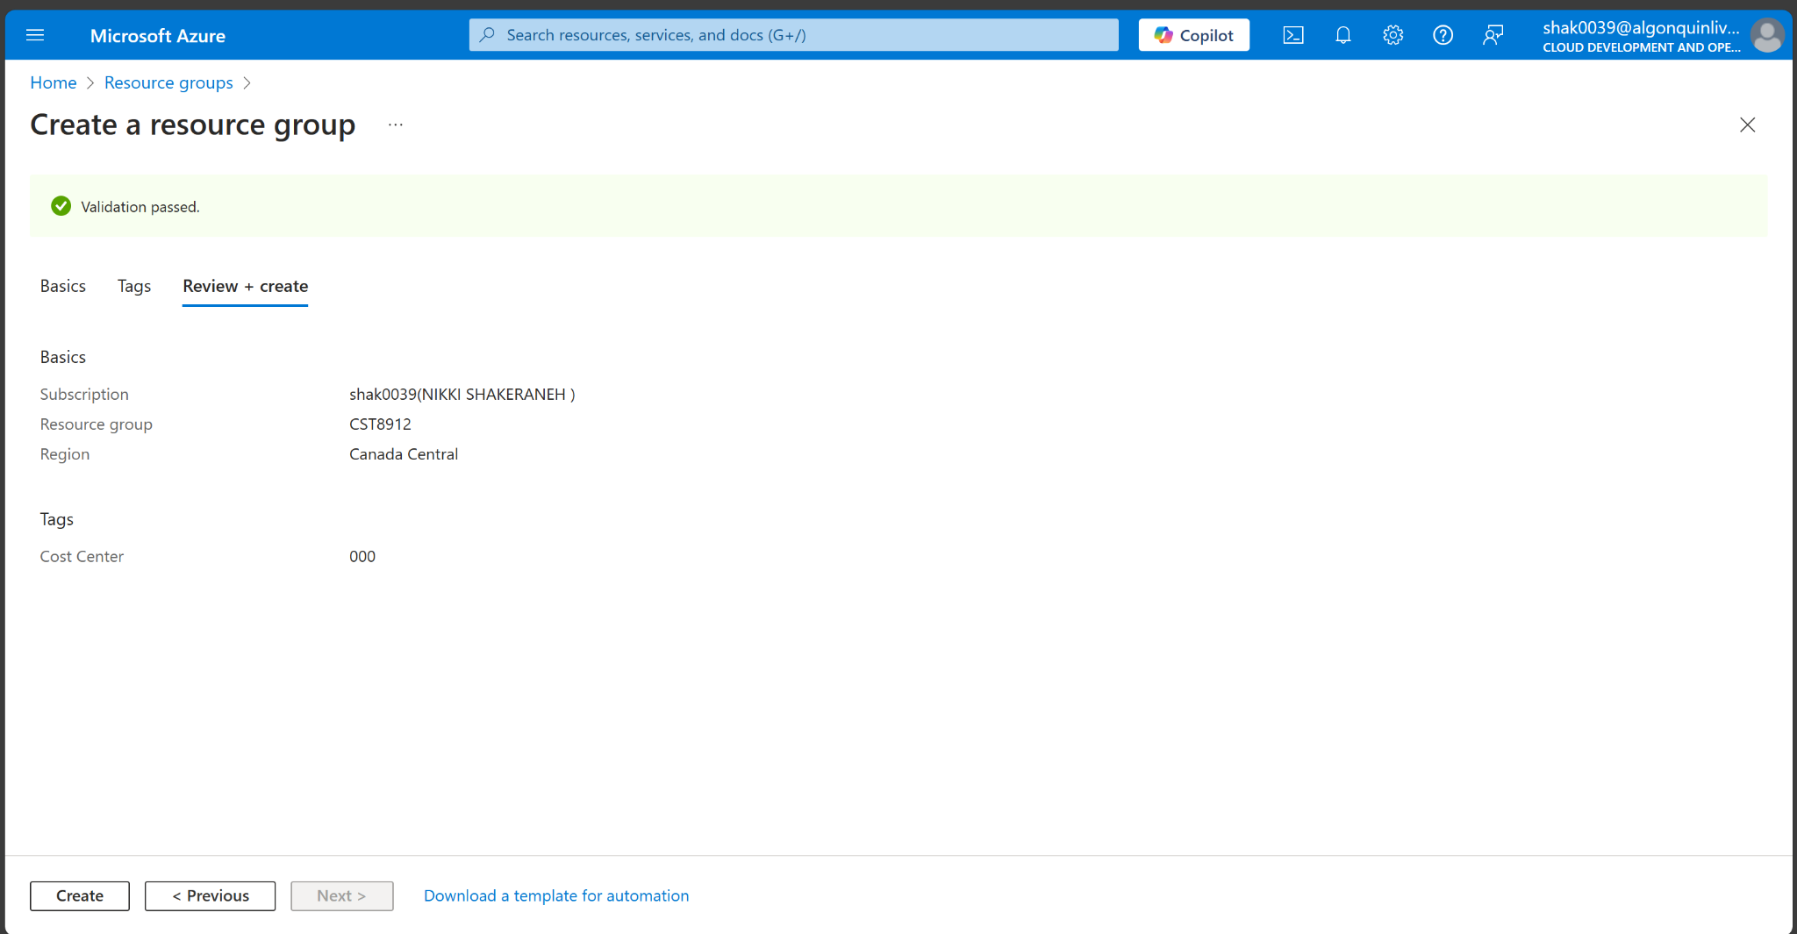

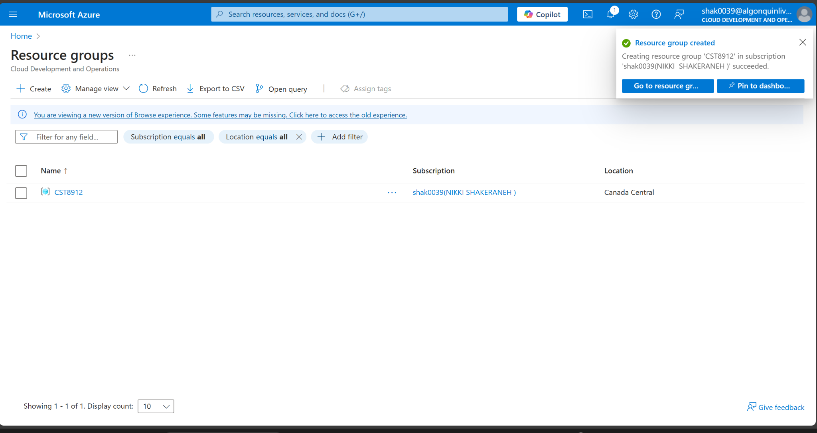

**Task 2: Enforce tagging via an Azure policy**

1. In the Azure portal, search for and select Policy.

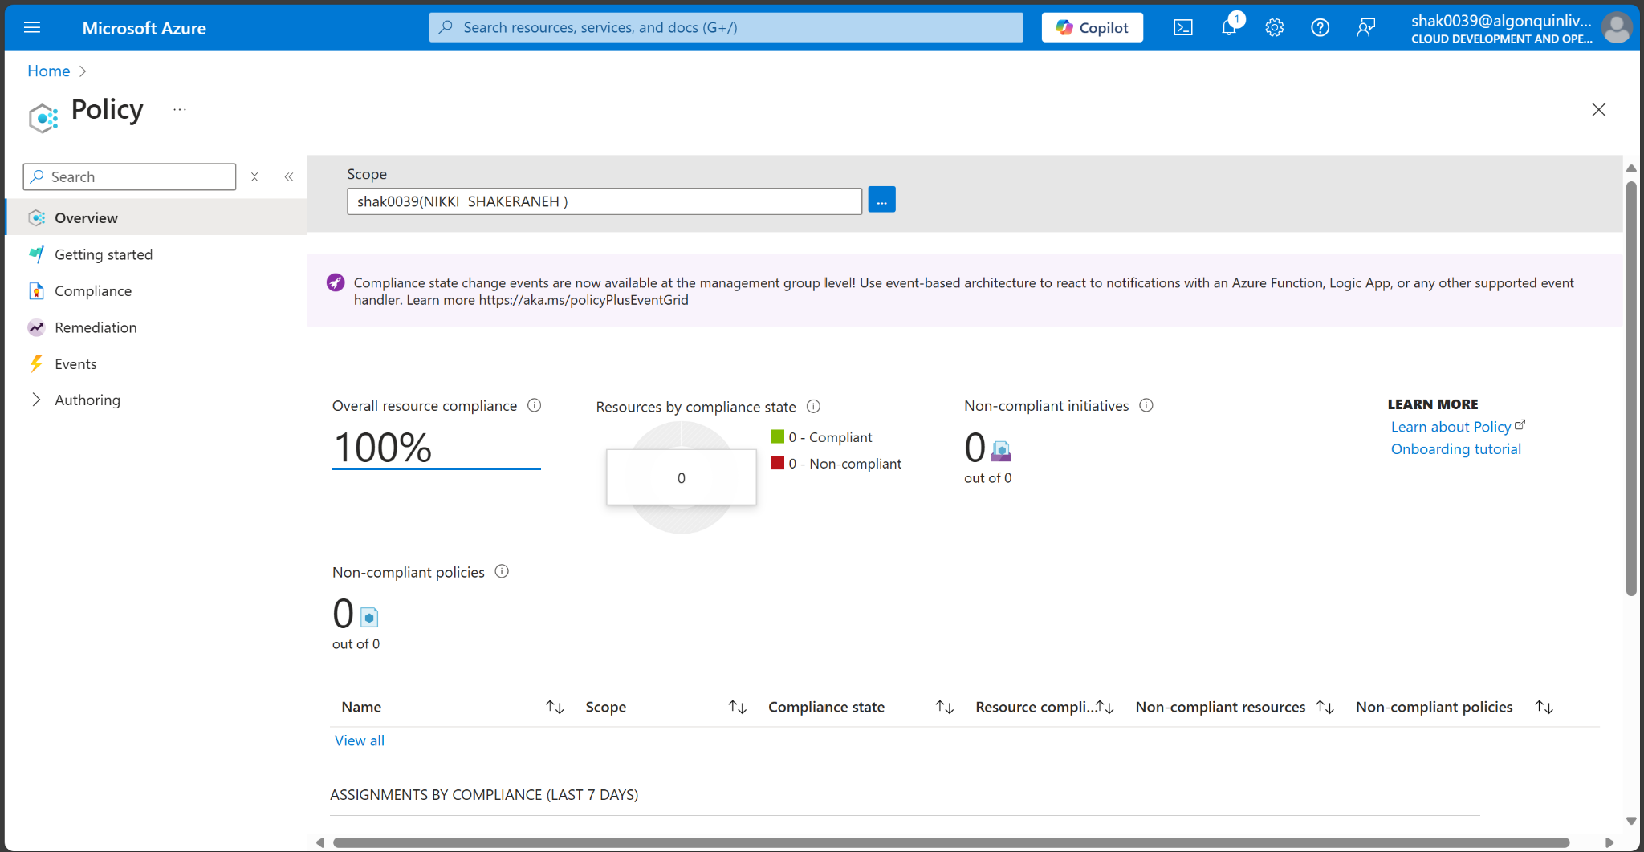

1. In the Authoring blade, select Definitions. Take a moment to browse through the list of built-in policy definitions that are available for you to use. Notice you can also search for a definition.

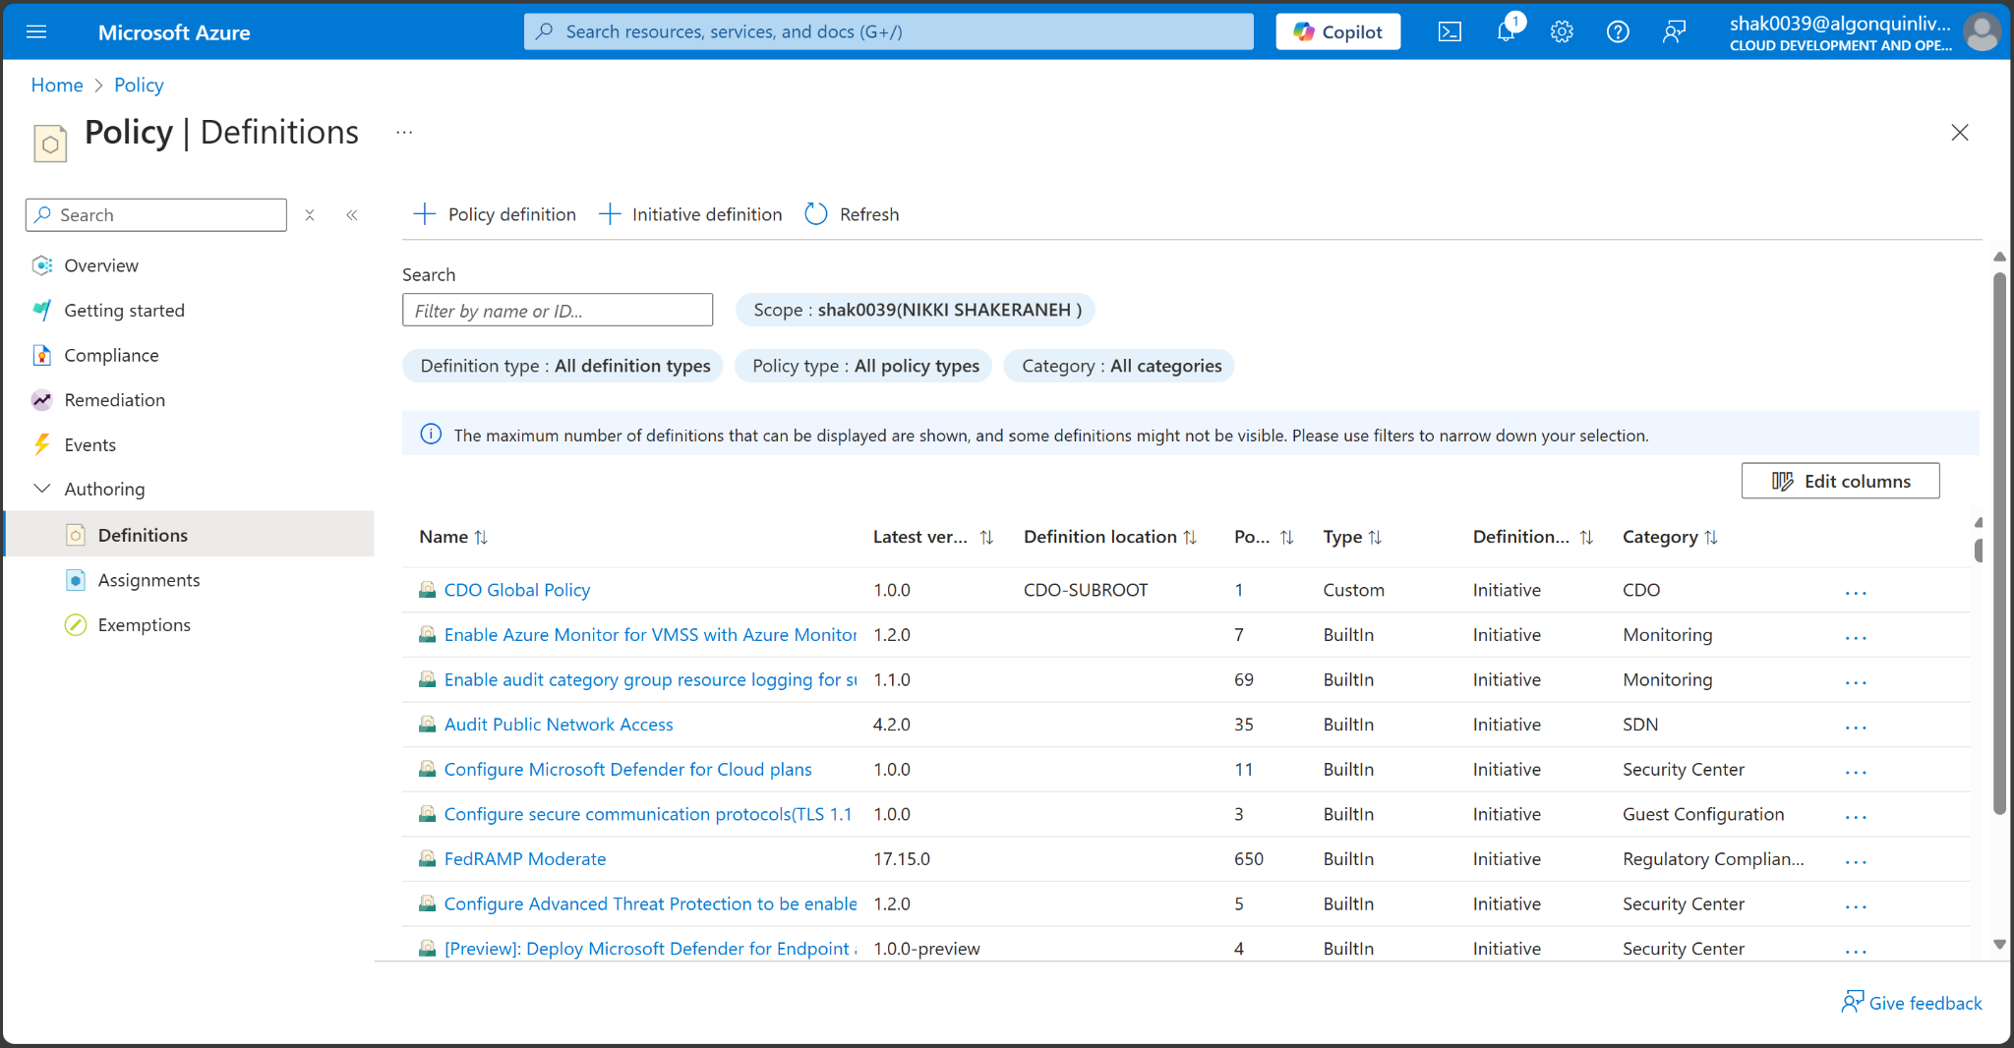

1. Search for “require a tag”

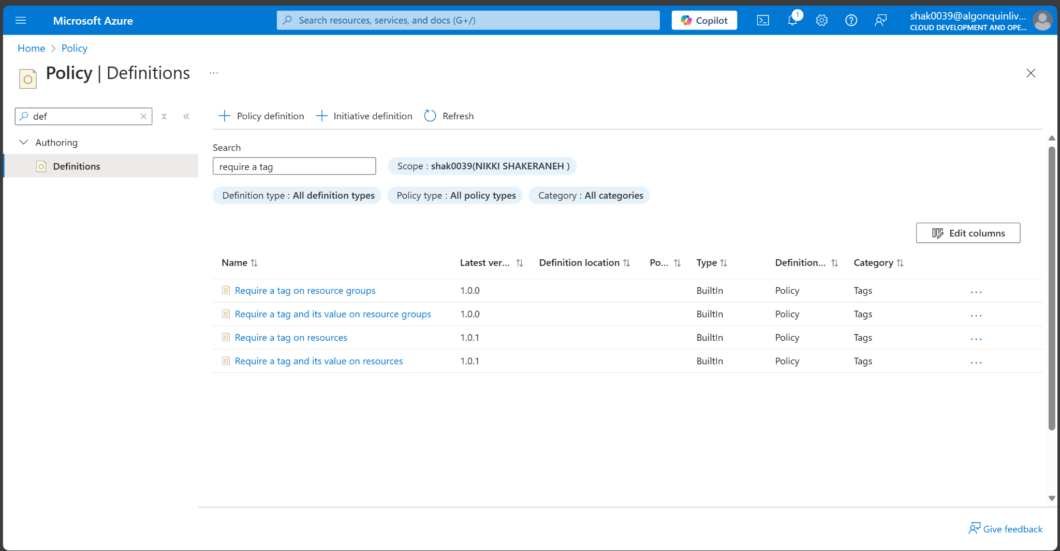

1. Screenshot of the policy definition.

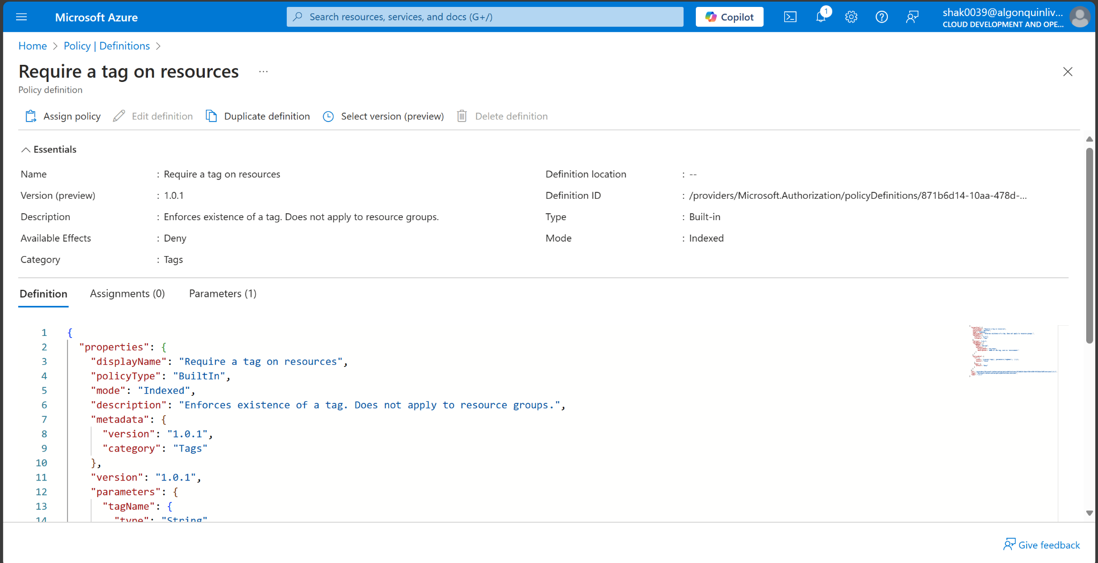

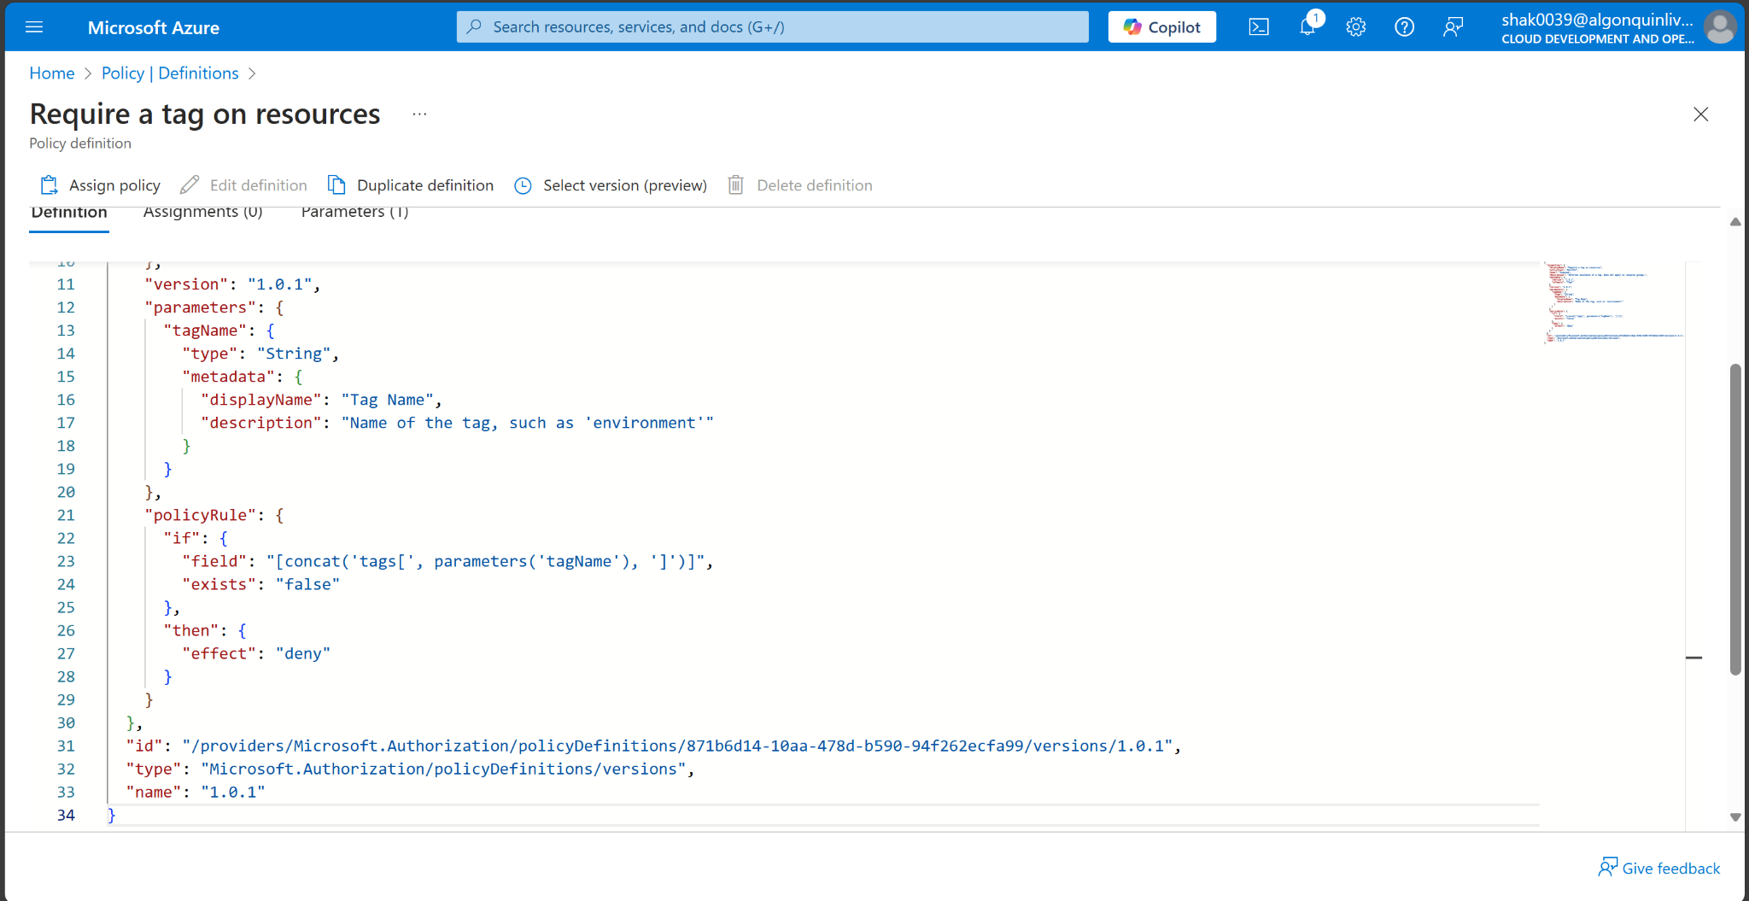

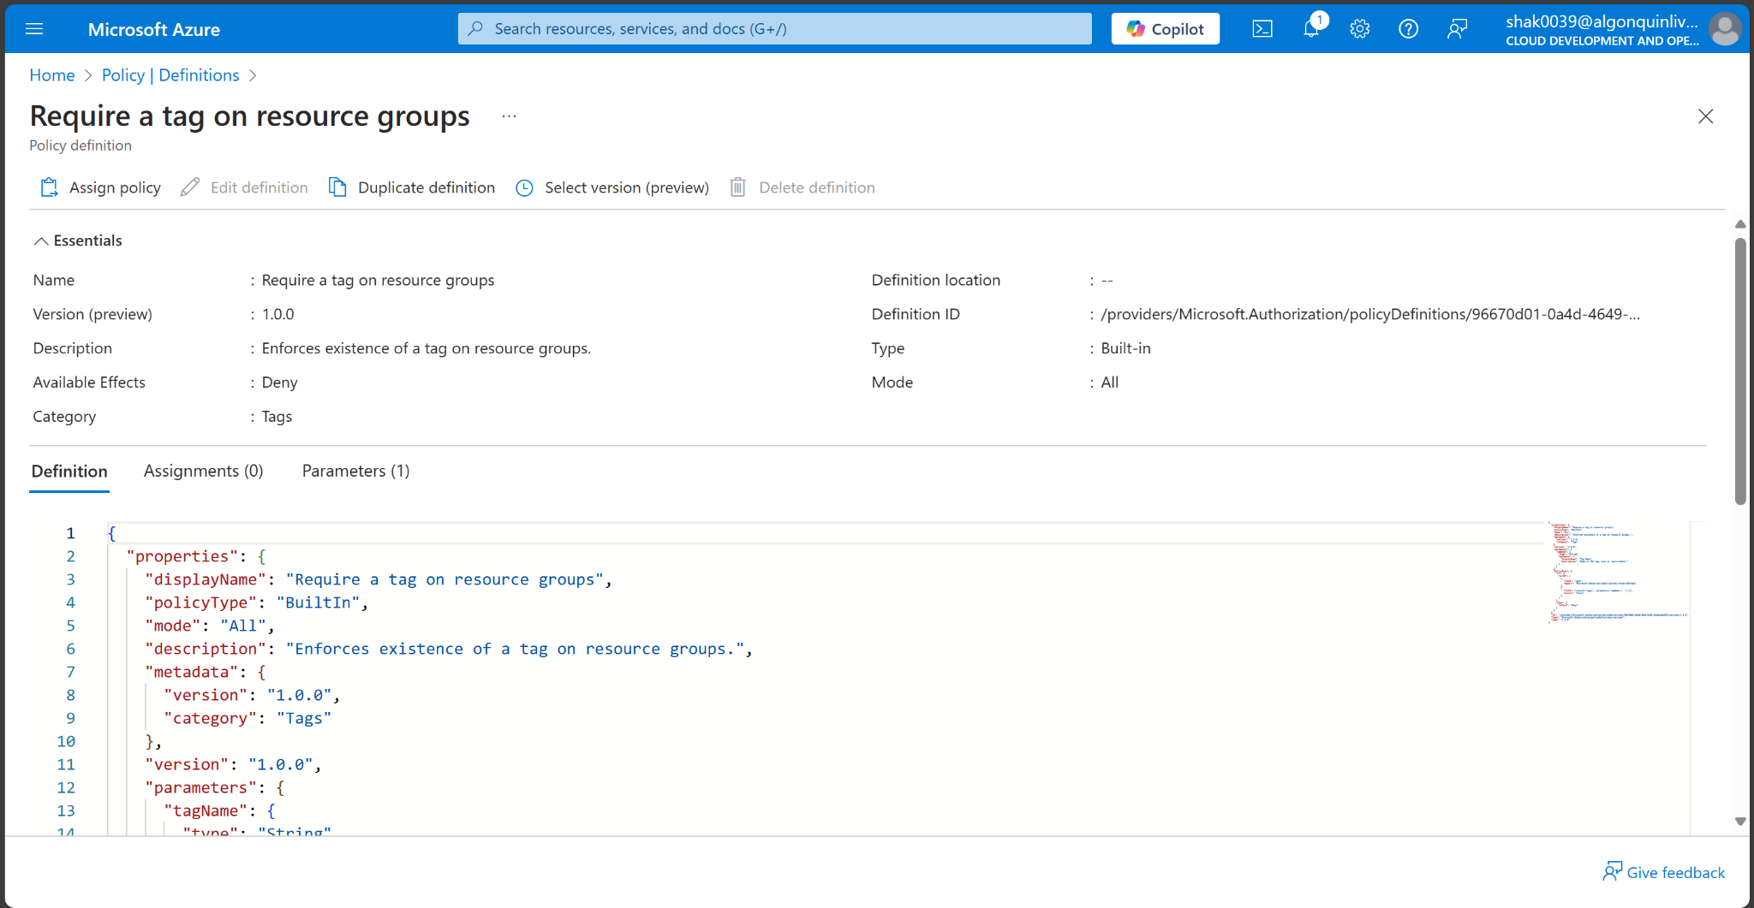

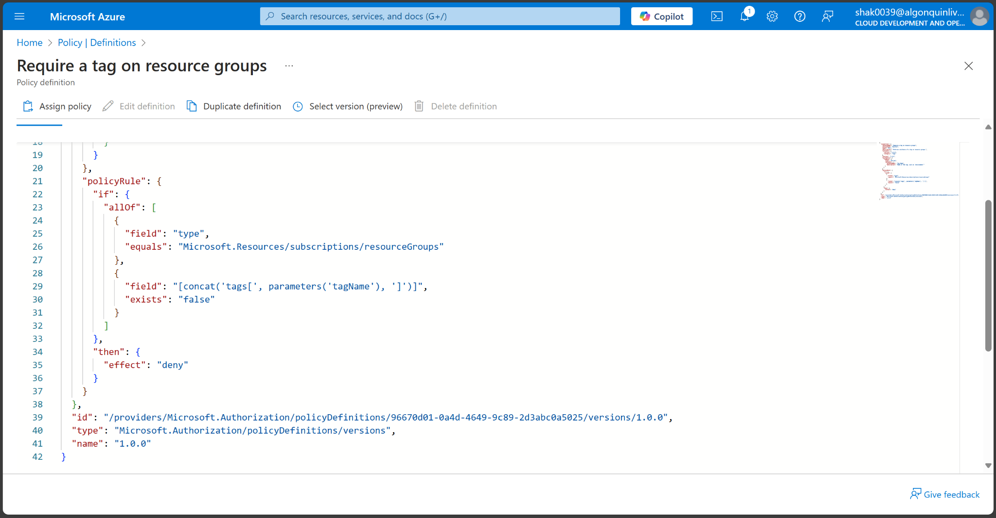

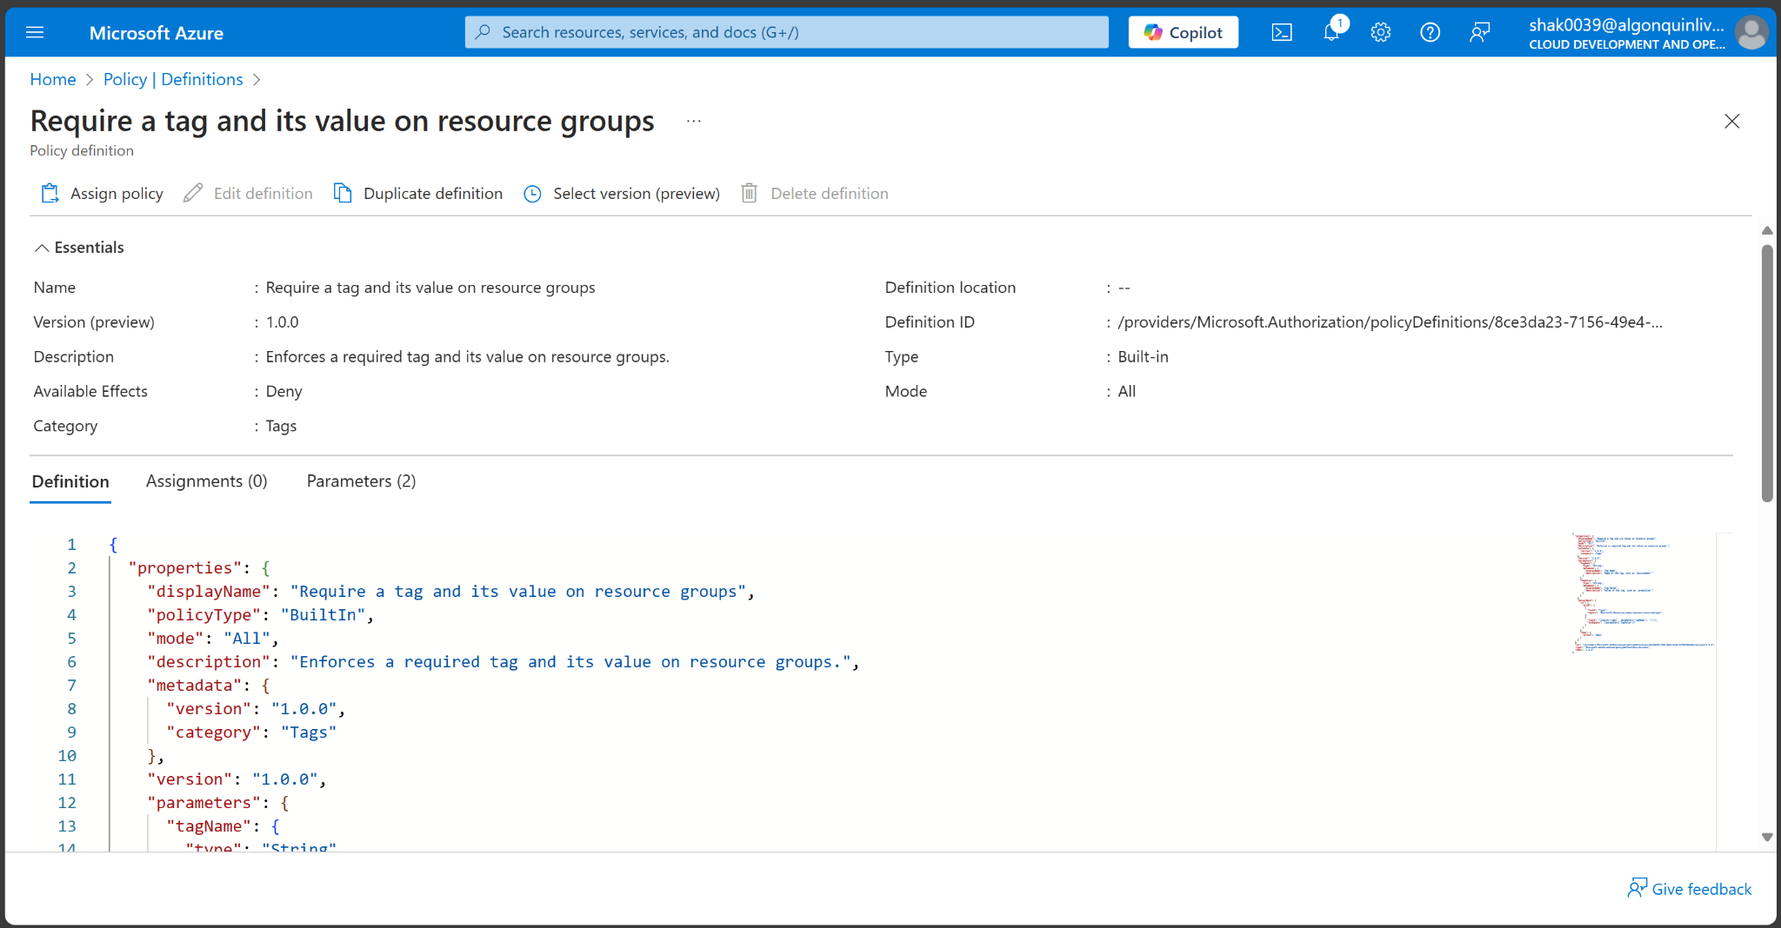

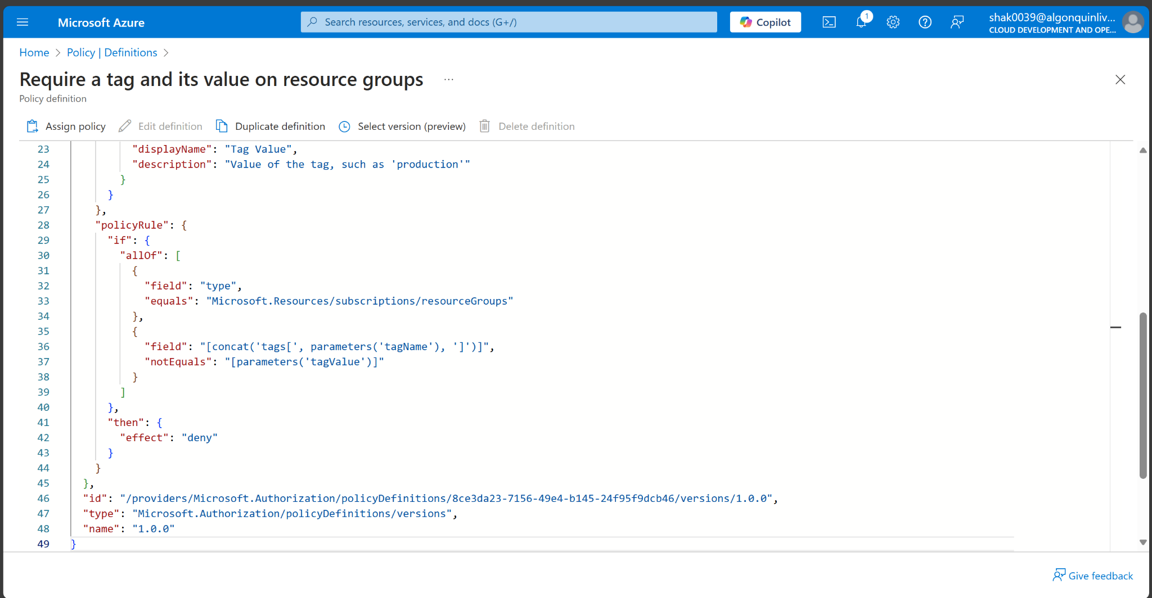

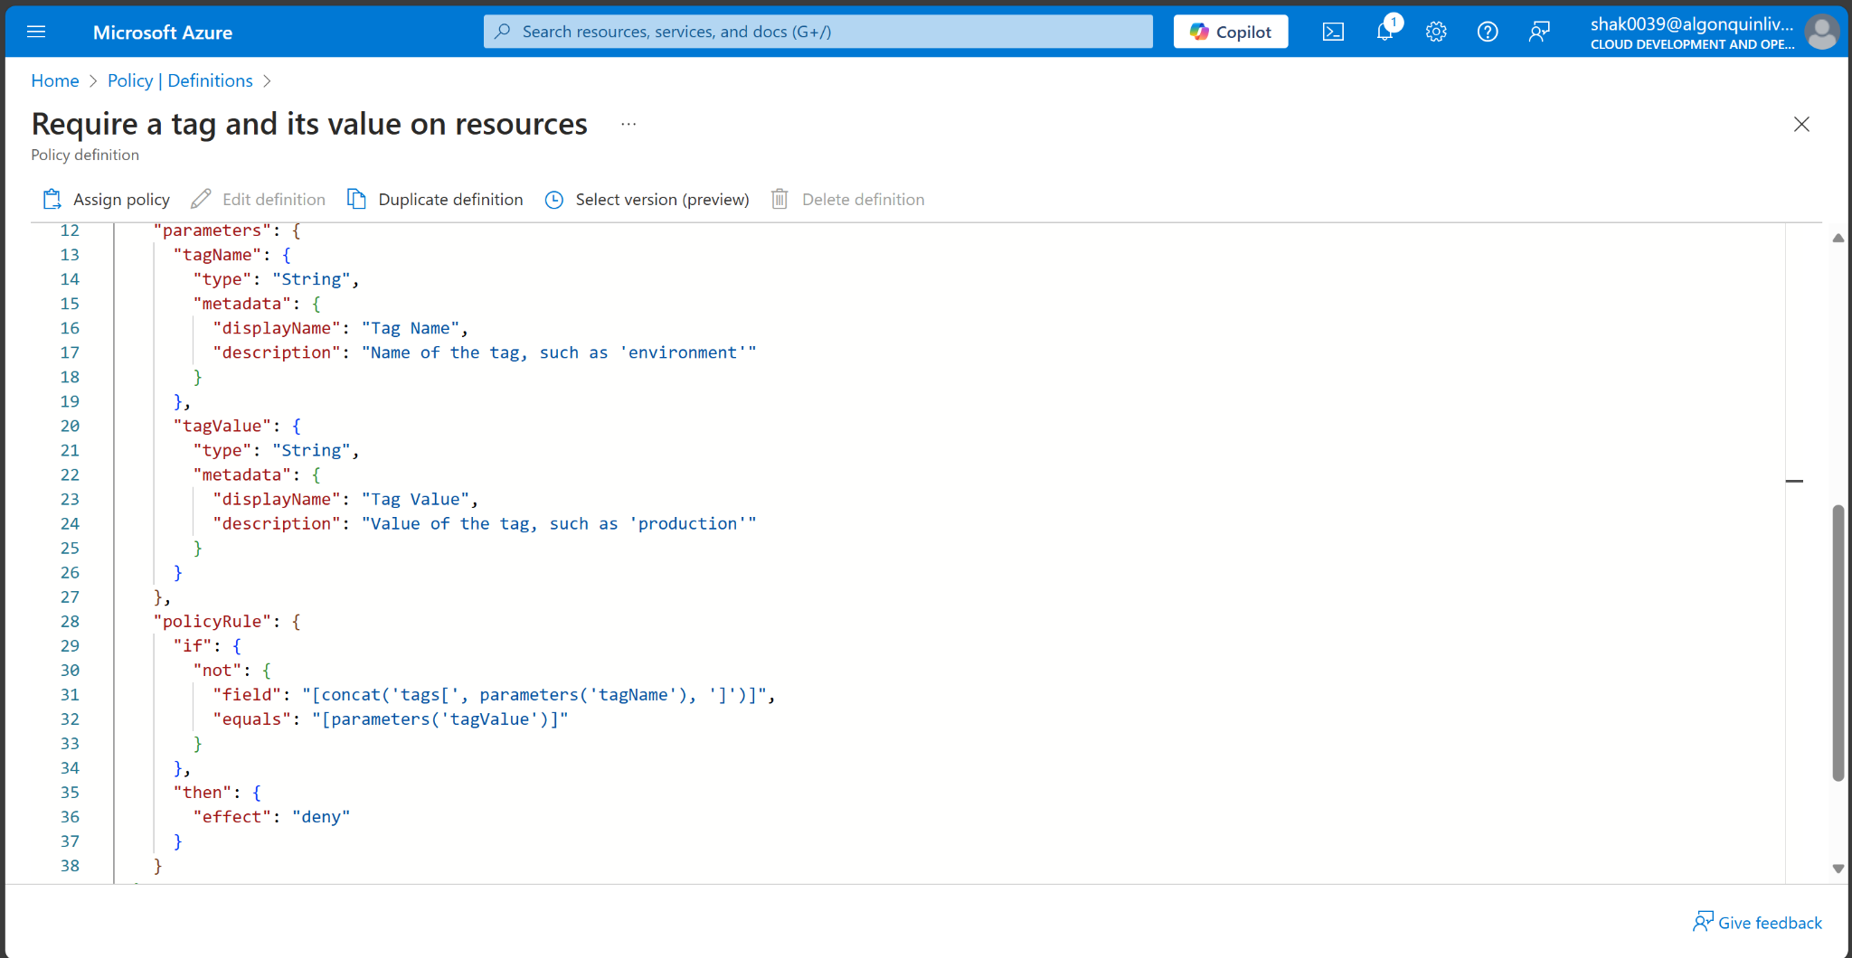

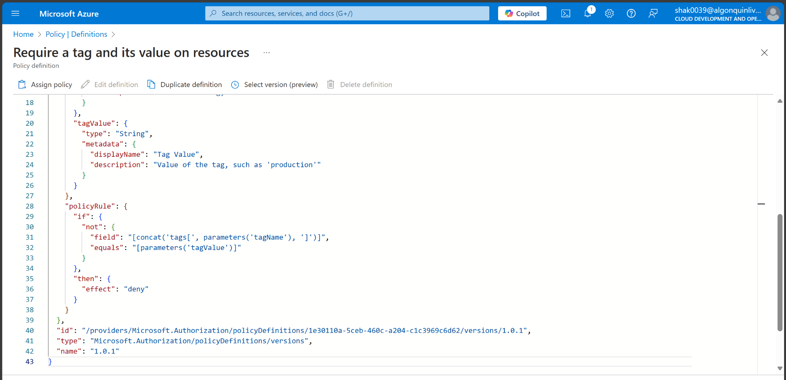

1. Click the entry representing the Require a tag and its value on resources built-in policy. Take a minute to review the definition.

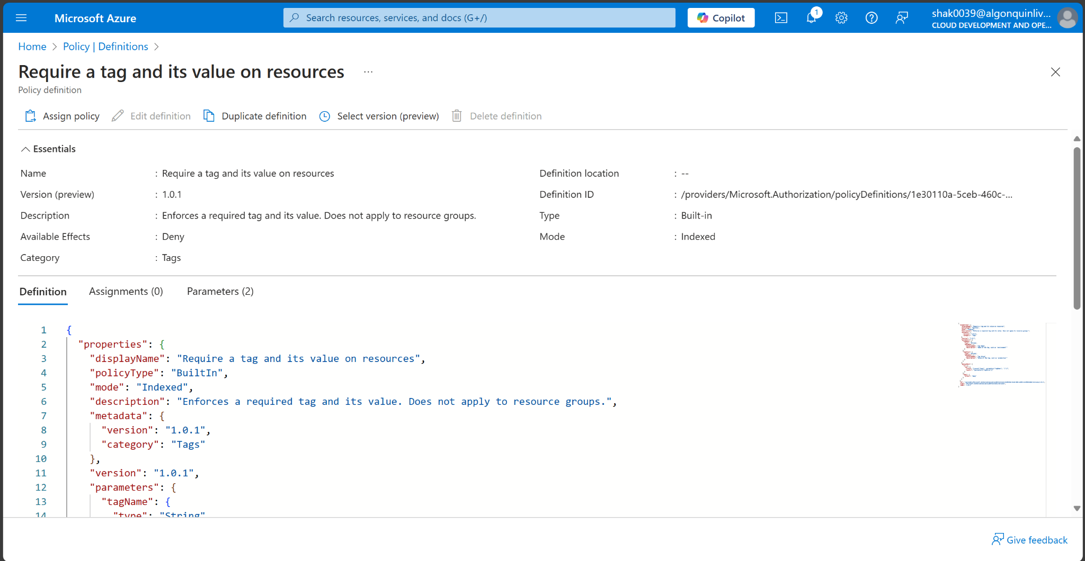

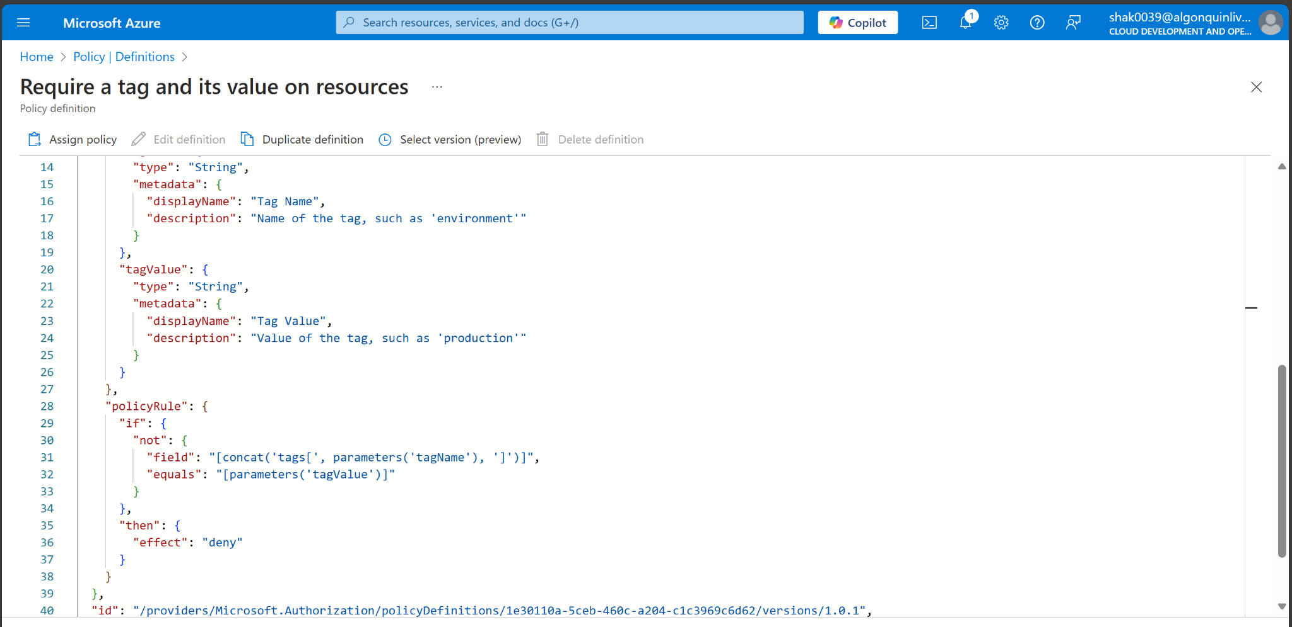

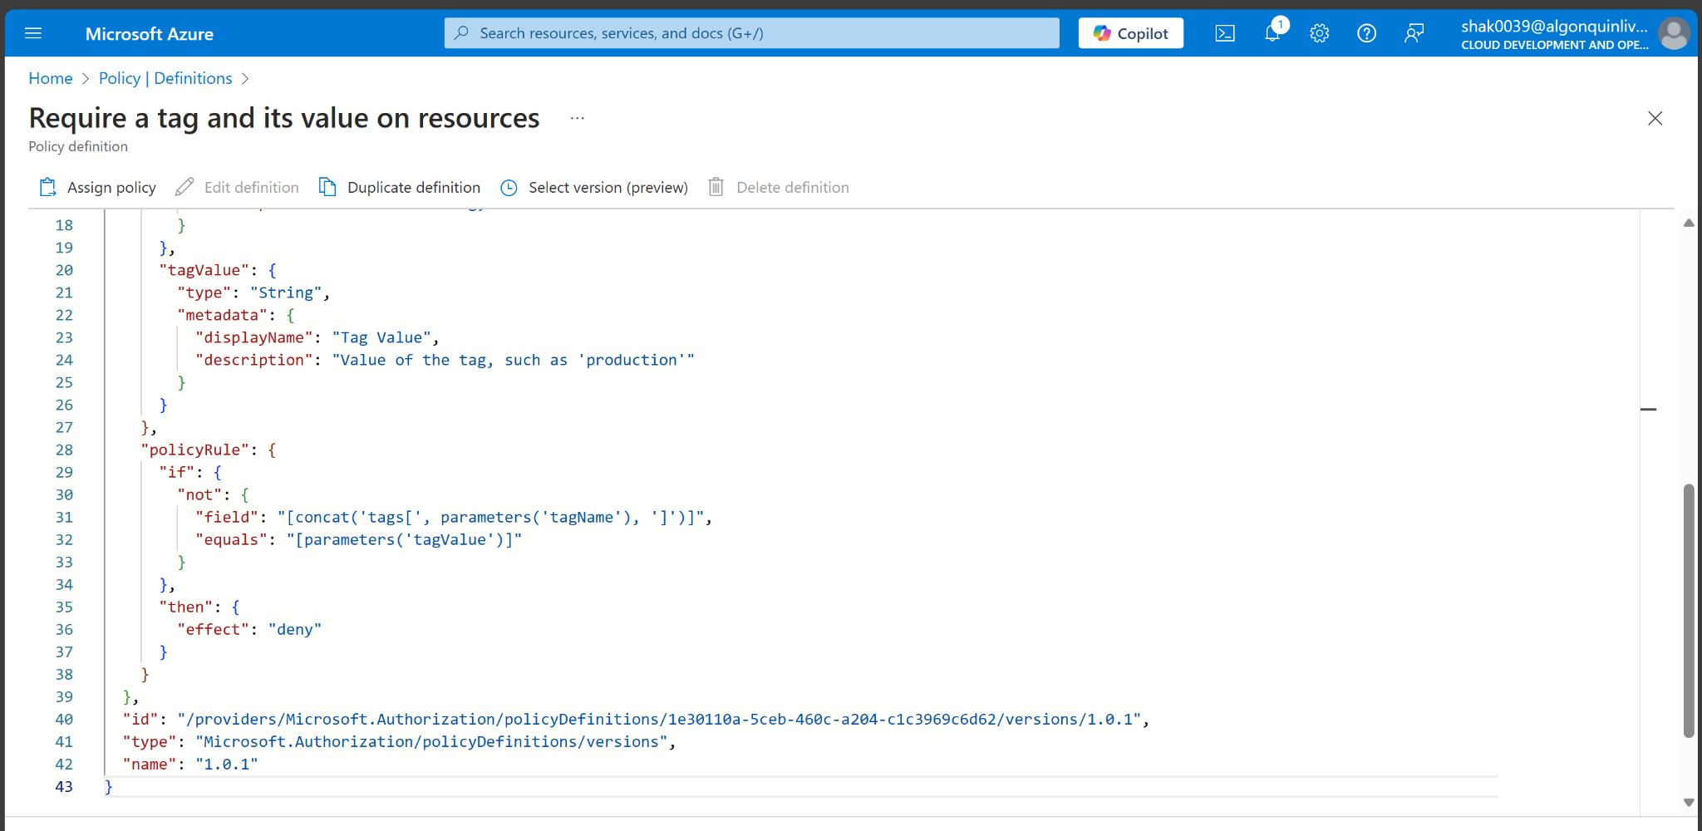

1. On the Require a tag and its value on resources built-in policy definition blade, click Assign.

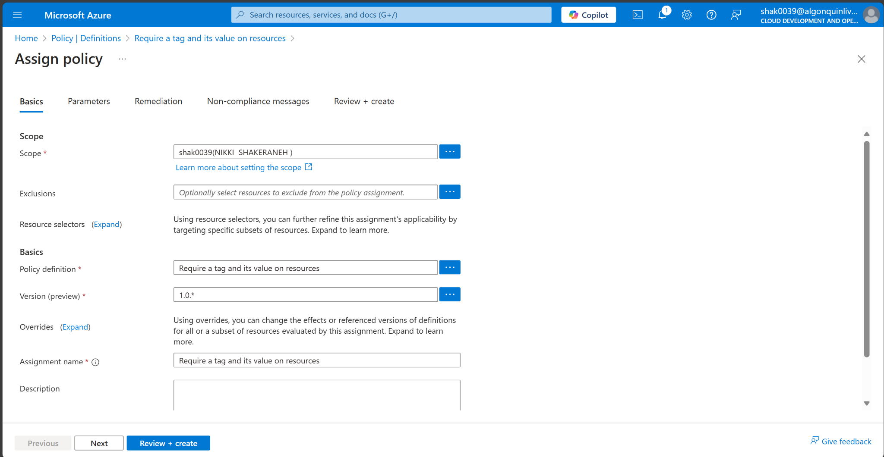

1. Specify the Scope by clicking the ellipsis button and selecting the following values. Click Select when you are done.

| Setting | Value |
| --- | --- |
| Subscription | your subscription |
| Resource Group | CST8912 |

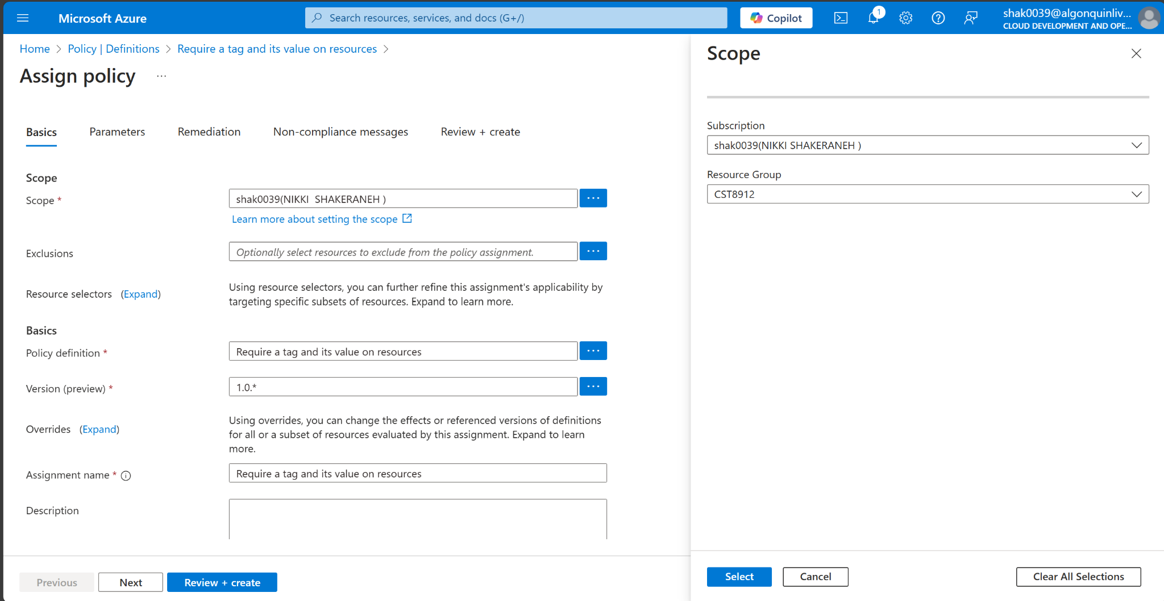

1. Configure the Basics properties of the assignment by specifying the following settings (leave others with their defaults):

| Setting | Value |
| --- | --- |
| Assignment name | Require Cost Center tag with Default value |
| Description | Require Cost Center tag with default value for all resources in the resource group |
| Policy enforcement | Enabled |

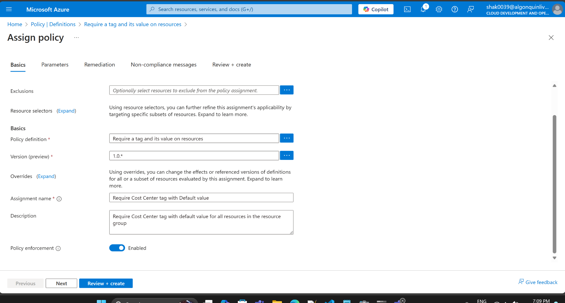

1. Note:
2. Click Next twice and set Parameters to the following values:

| Setting | Value |
| --- | --- |
| Tag Name | Cost Center |
| Tag Value | 000 |

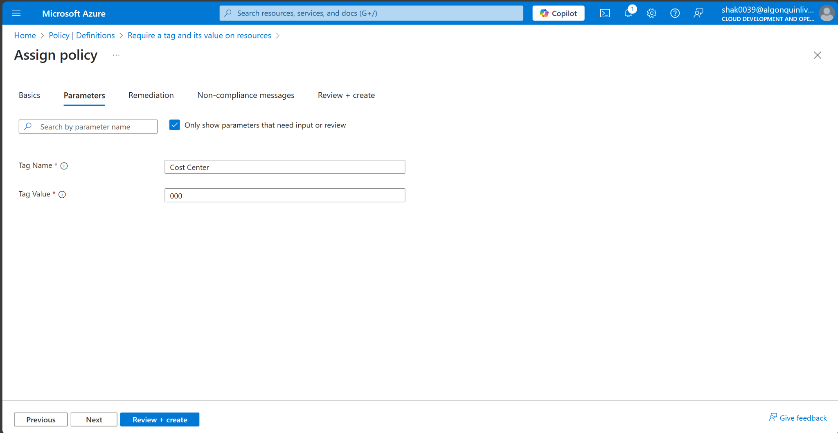

1. Click Next and review the Remediation tab. Leave the Create a Managed Identity checkbox unchecked

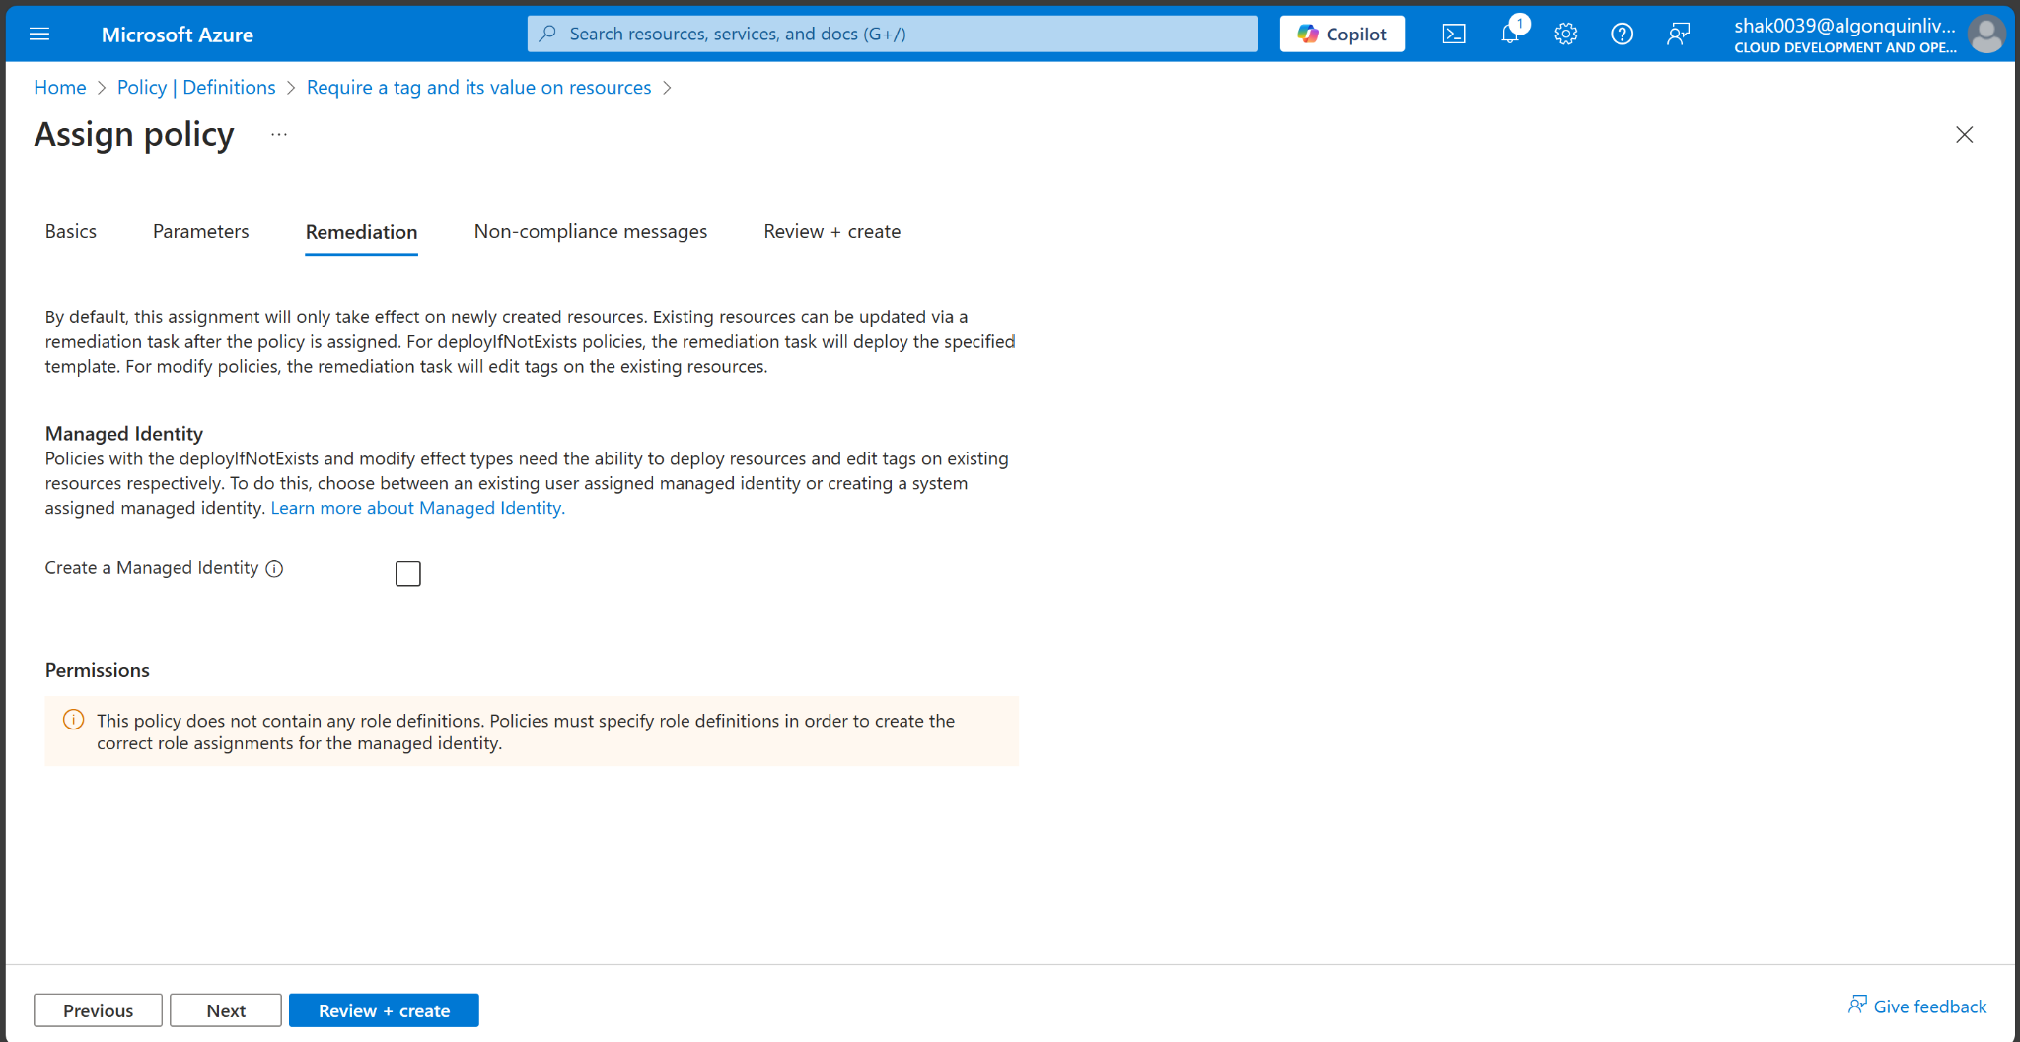

1. Click Review + Create and then click Create.

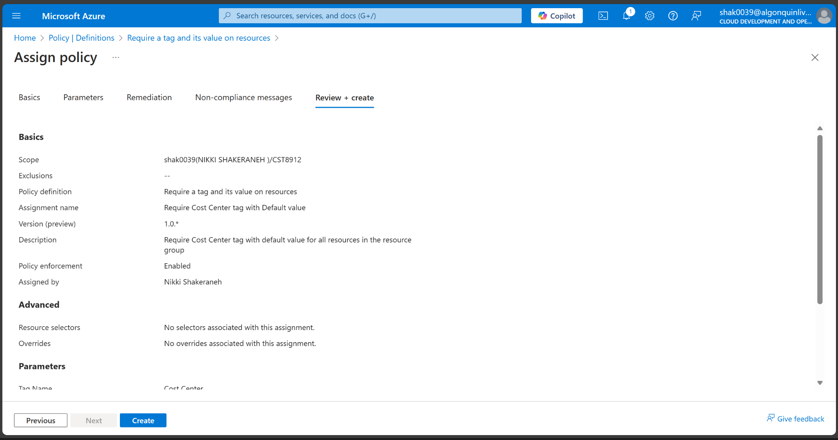

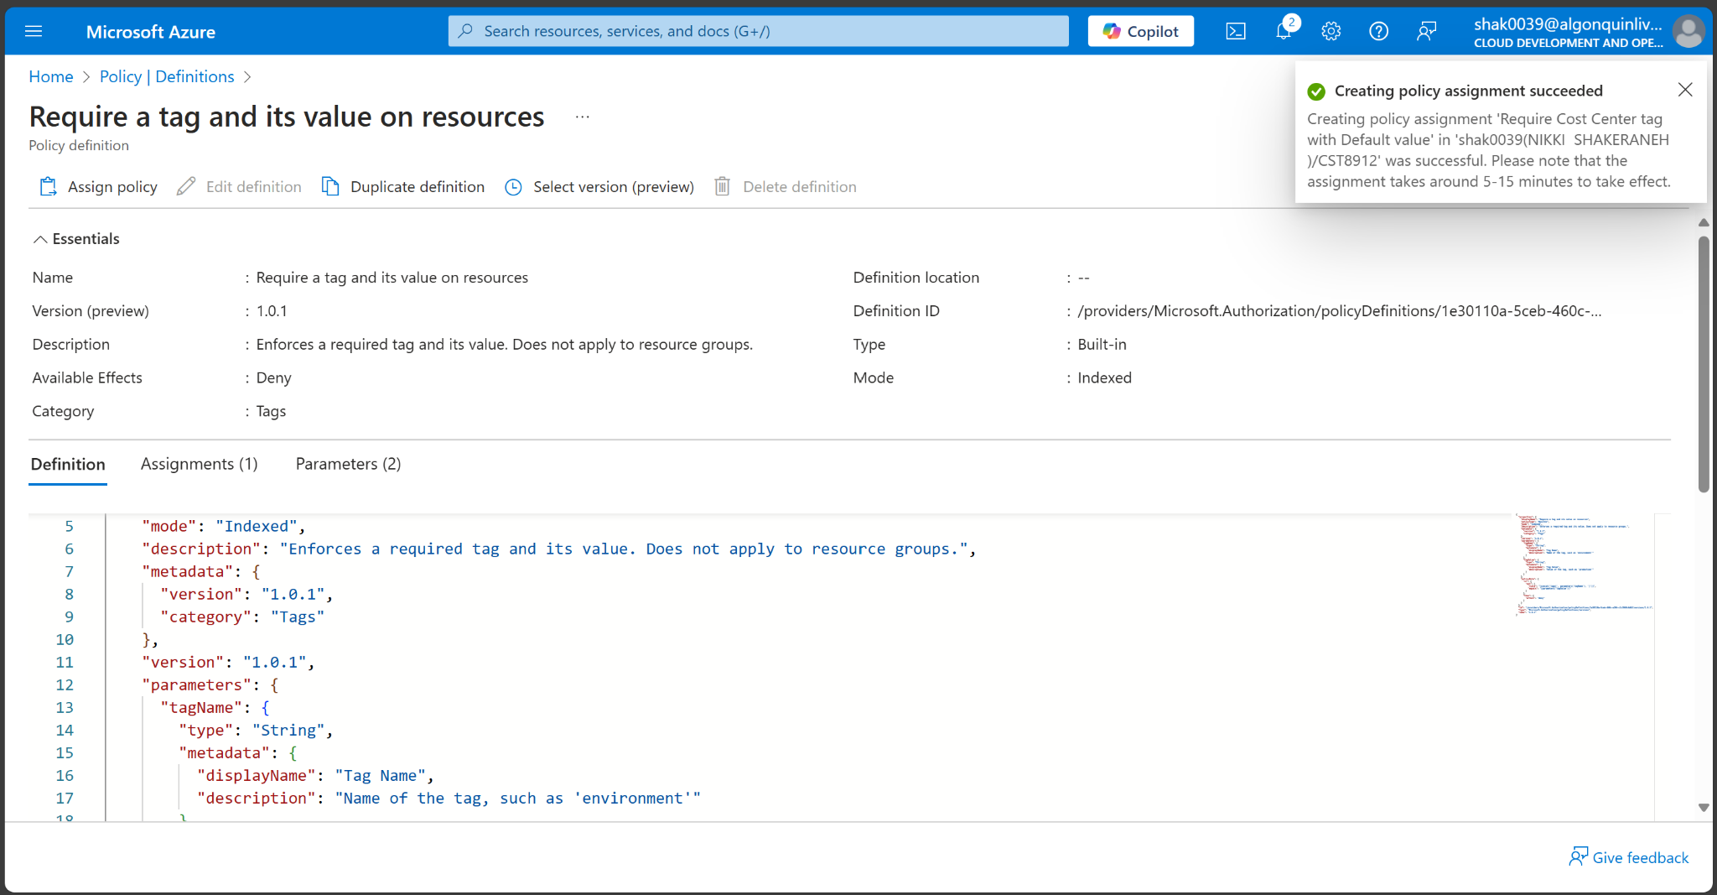

1. Note: Now you will verify that the new policy assignment is in effect by attempting to create an Azure Storage account in the resource group. You will create the storage account without adding the required tag.
2. Note: It might take between 5 and 10 minutes for the policy to take effect.
3. In the portal, search for and select Storage Account, and select + Create.
4. On the Basics tab of the Create storage account blade, complete the configuration.

| Setting | Value |
| --- | --- |
| Resource group | CST8912 |
| Storage account name | any globally unique combination of between 3 and 24 lower case letters and digits, starting with a letter |

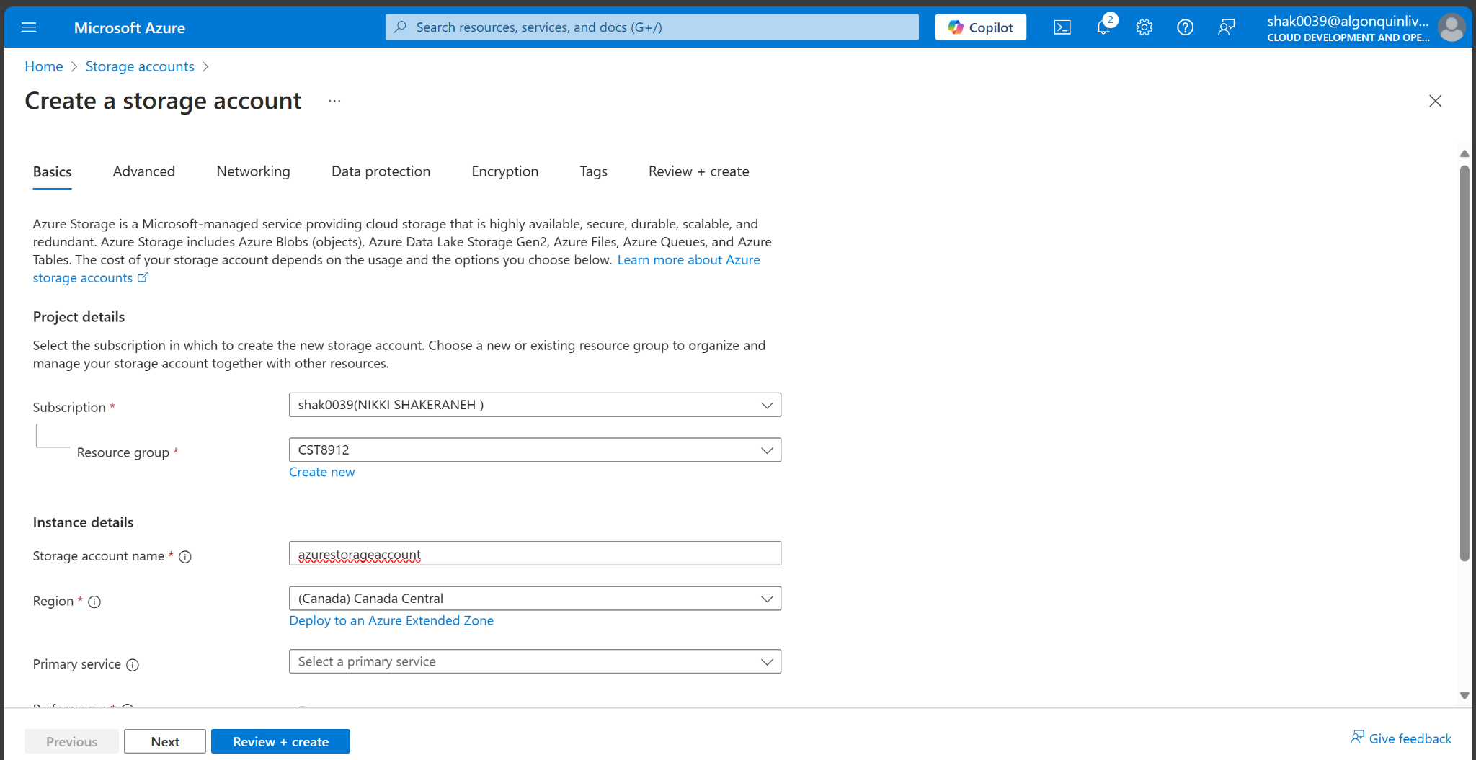

1. Select Review and then click Create.

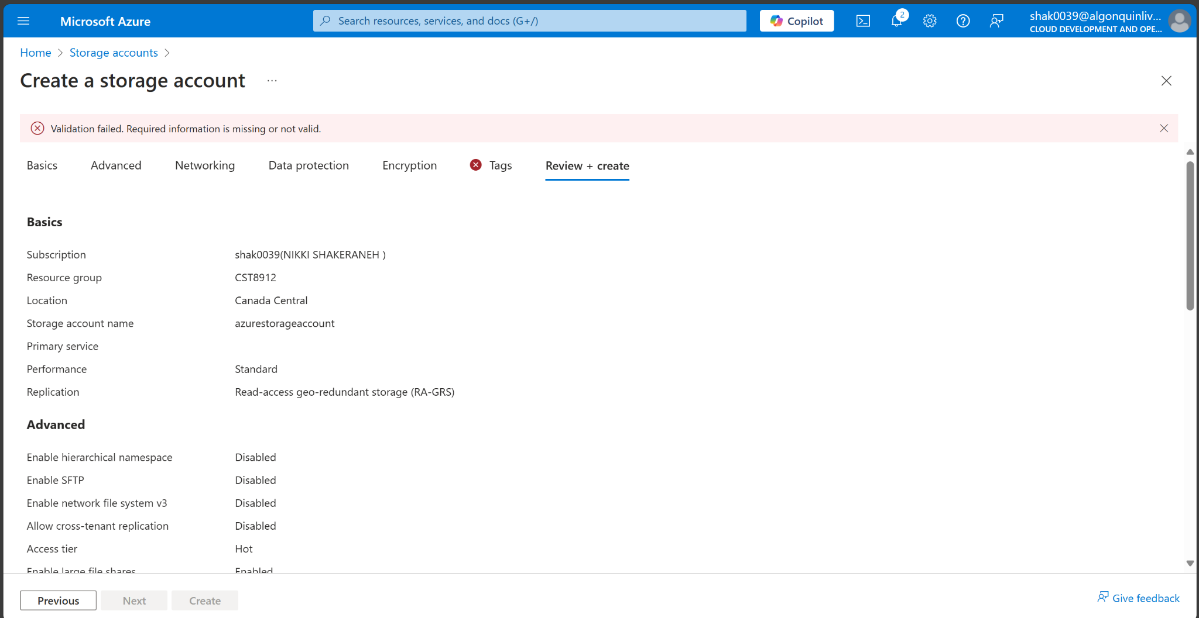

1. You should receive a Validation failed message. View the message to identify the reason for the failure. Verify the error message states that the resource deployment was disallowed by the policy.

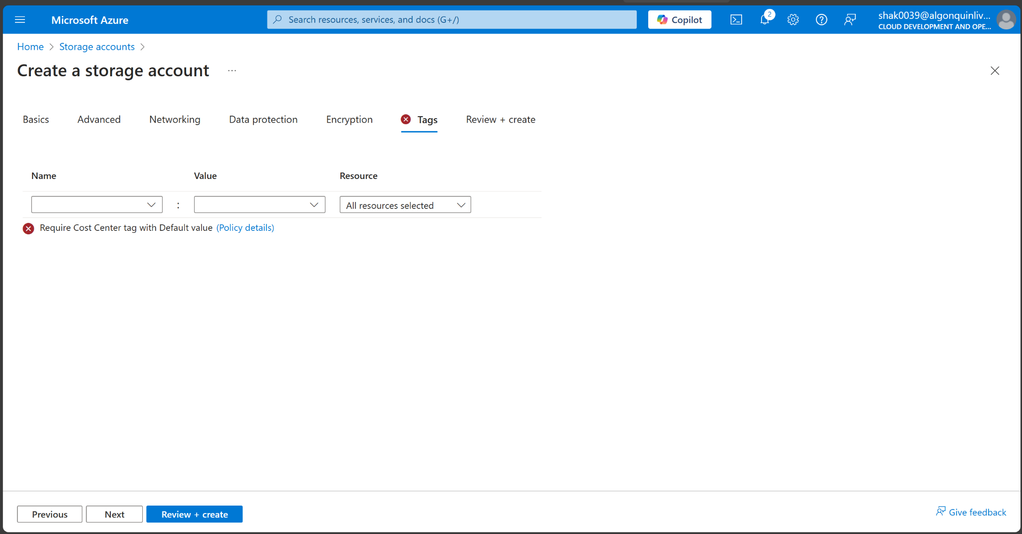

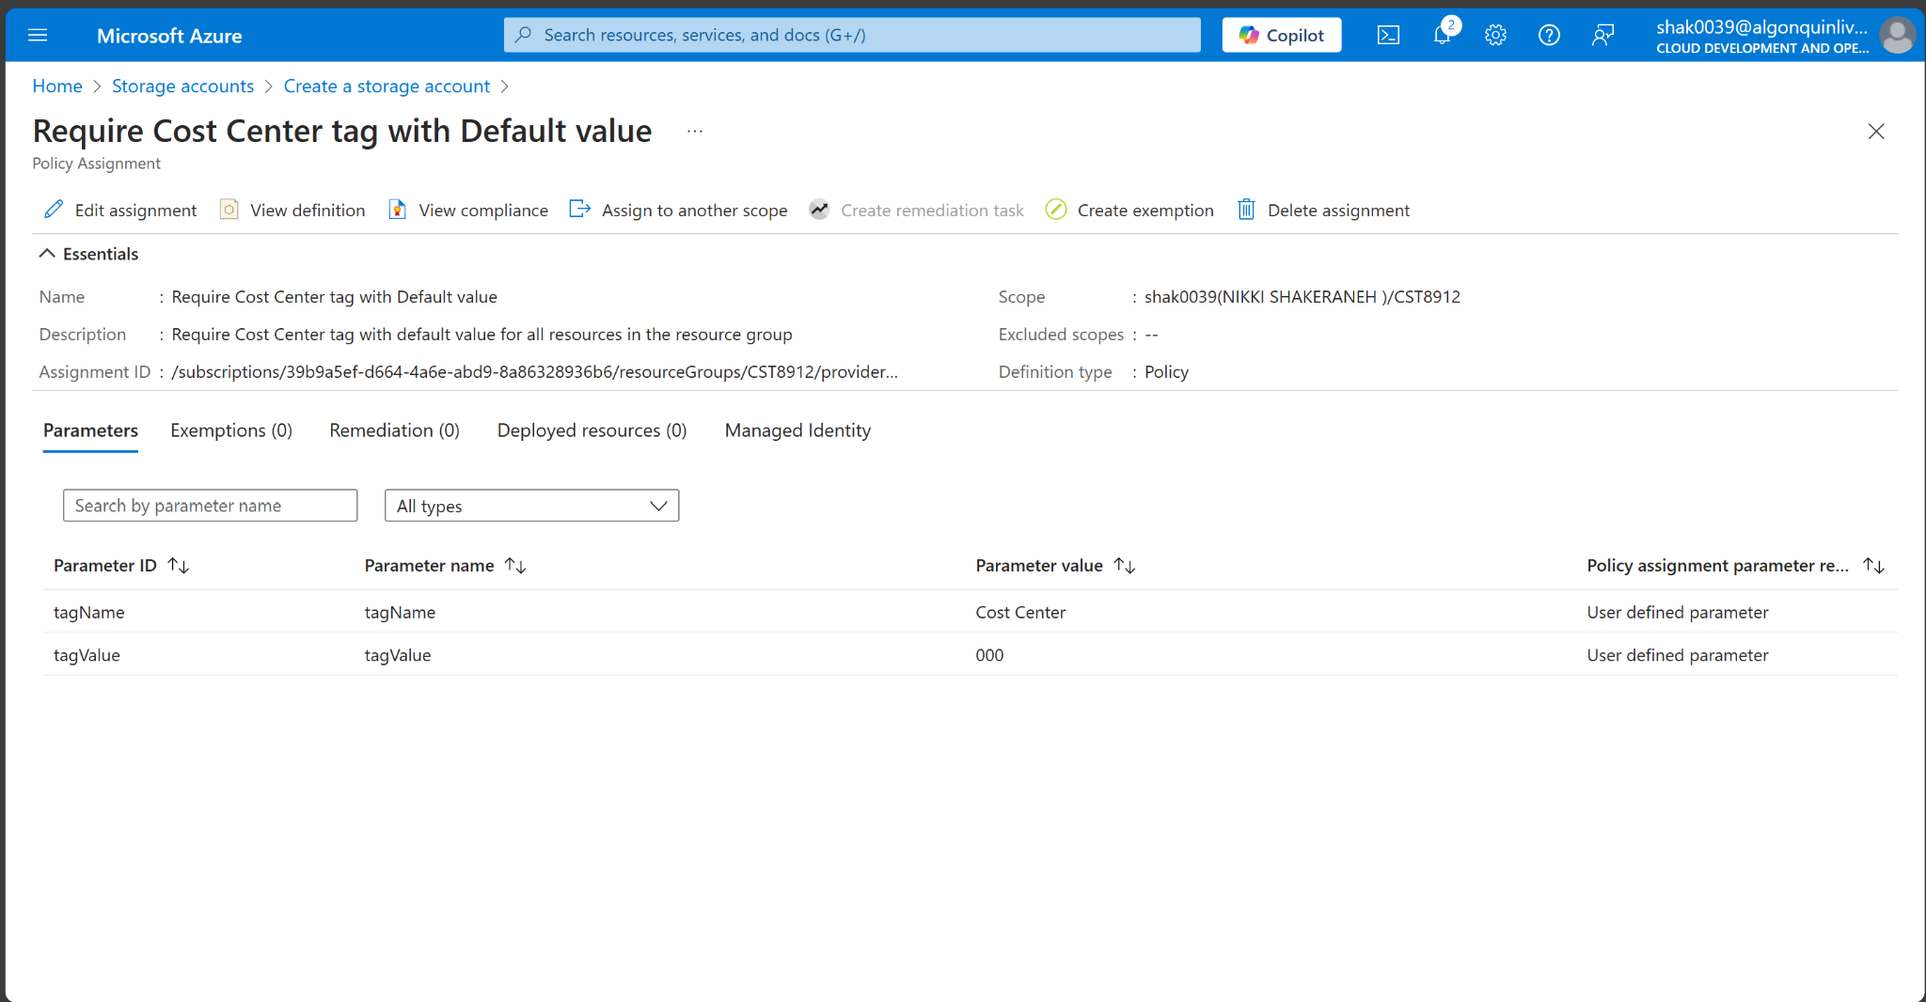

**Task 3**: Apply tagging via an Azure policy

1. In this task, we will use the new policy definition to remediate any non-compliant resources. In this scenario, we will make any child resources of a resource group inherit the Cost Center tag that was defined on the resource group.
2. In the Azure portal, search for and select Policy.
3. In the Authoring section, click Assignments.

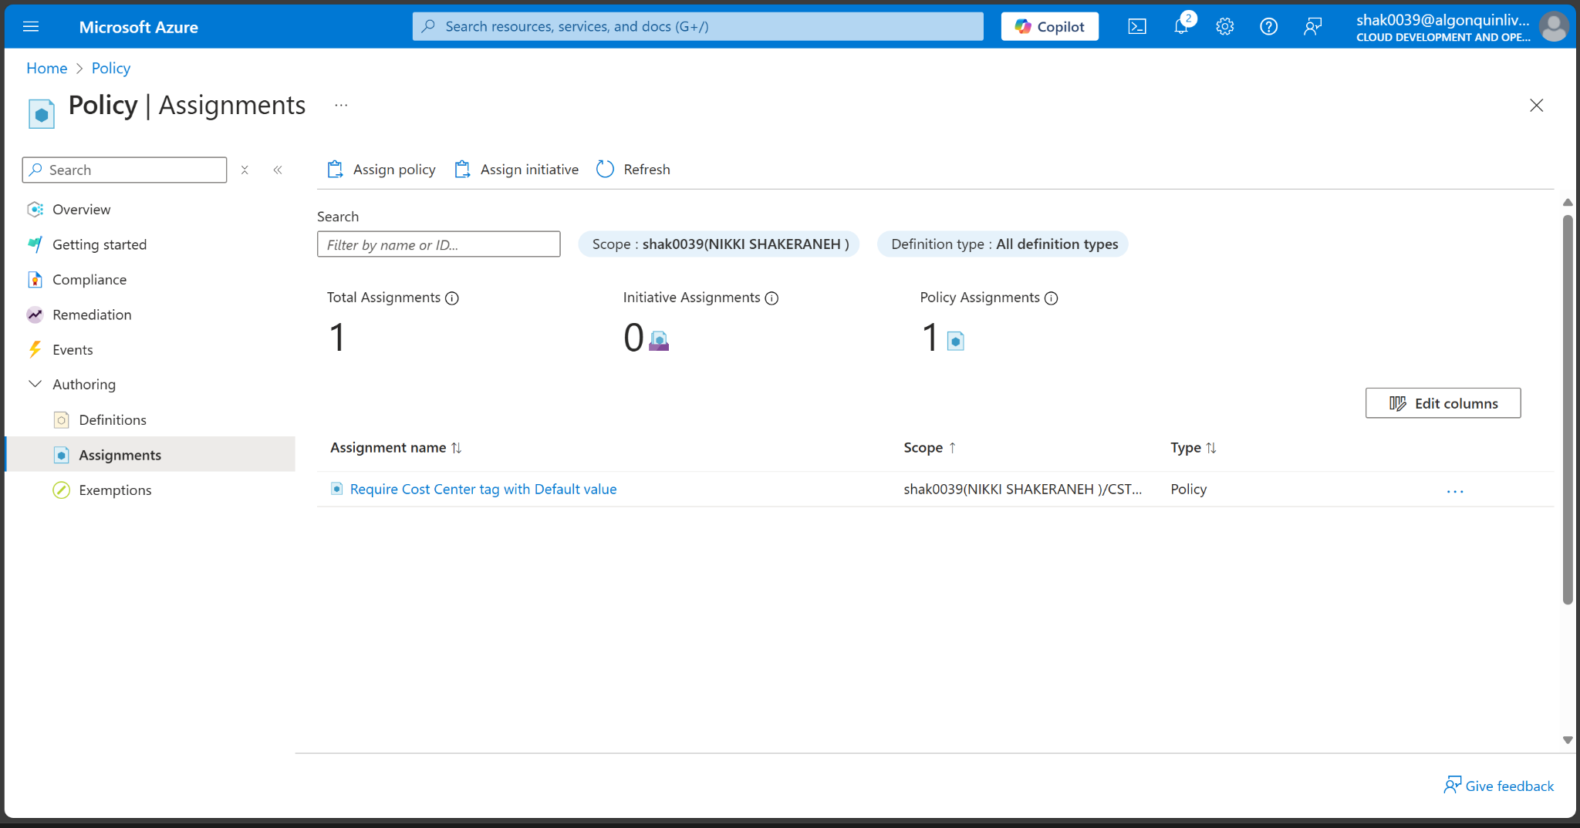

1. In the list of assignments, click the ellipsis icon in the row representing the Require Cost Center tag with Default value policy assignment and use the Delete assignment menu item to delete the assignment.

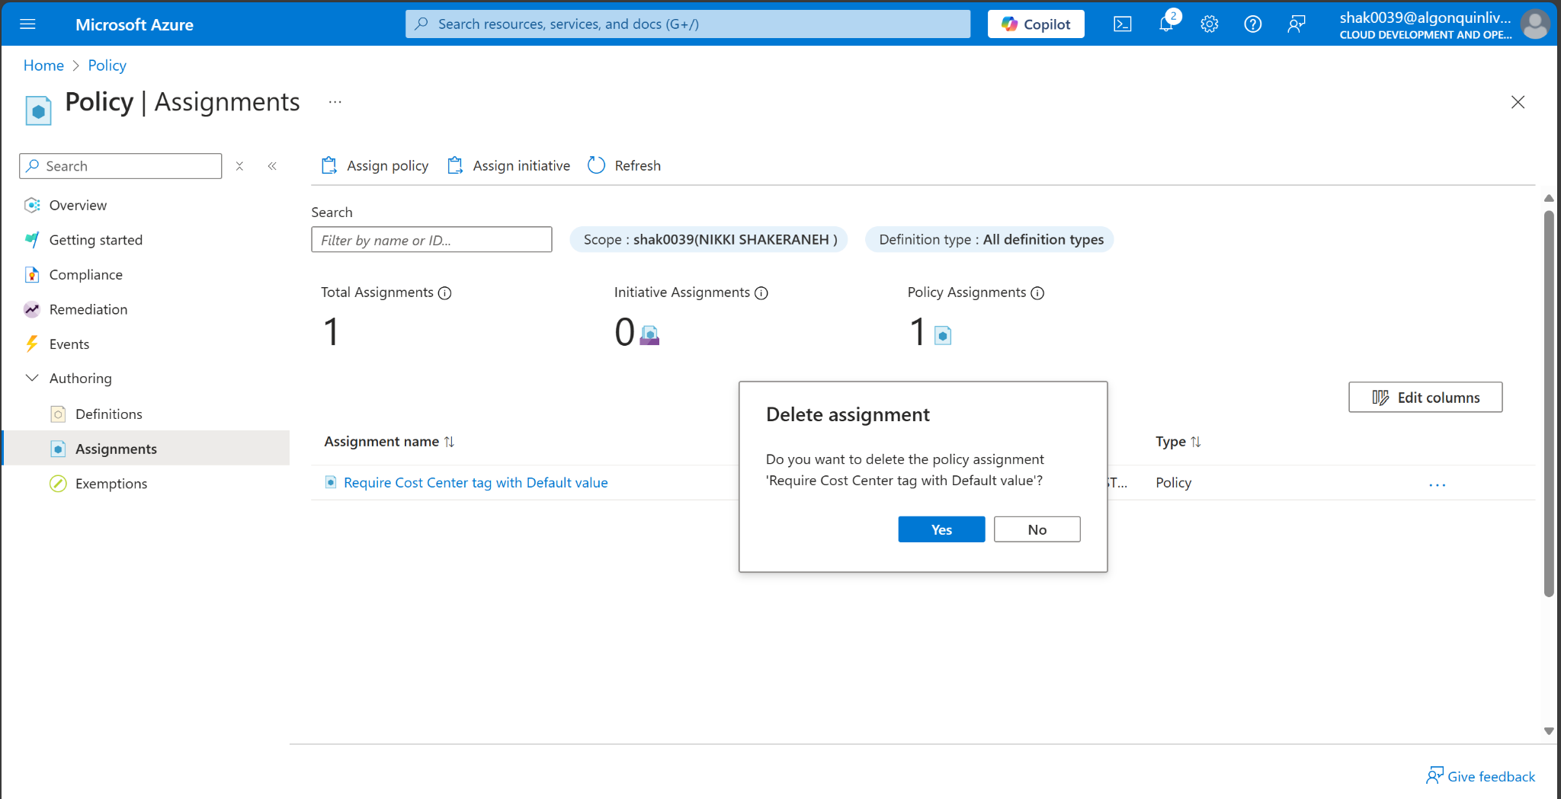

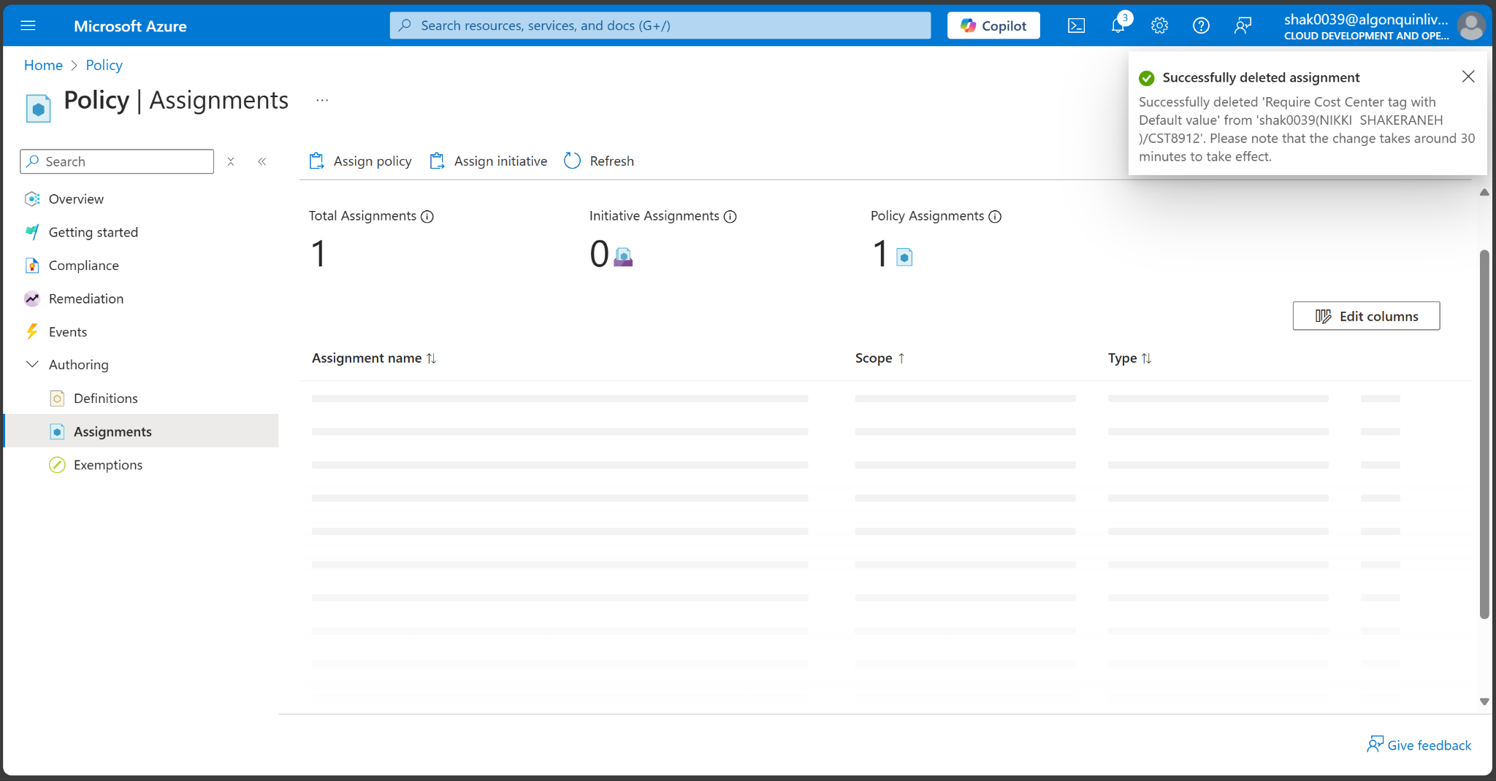

1. Click Assign policy and specify the Scope by clicking the ellipsis button and selecting the following values:

| Setting | Value |
| --- | --- |
| Subscription | your Azure subscription |
| Resource Group | CST8912 |

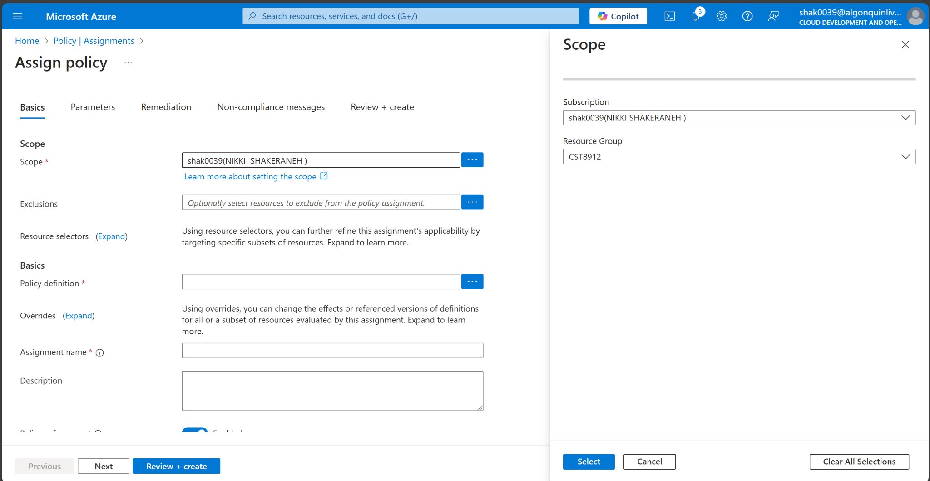

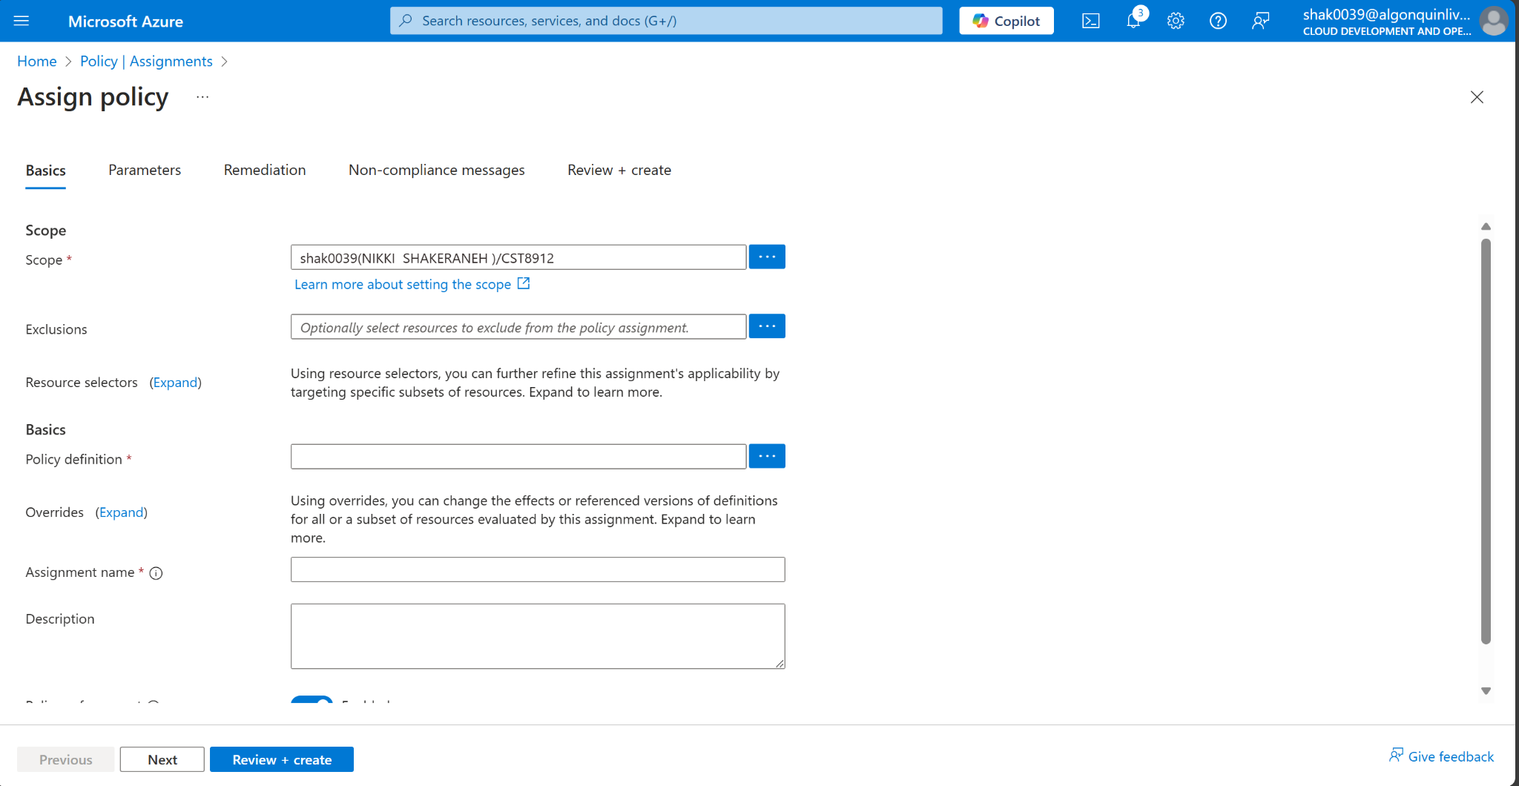

1. To specify the Policy definition, click the ellipsis button and then search for and select Inherit a tag from the resource group if missing.

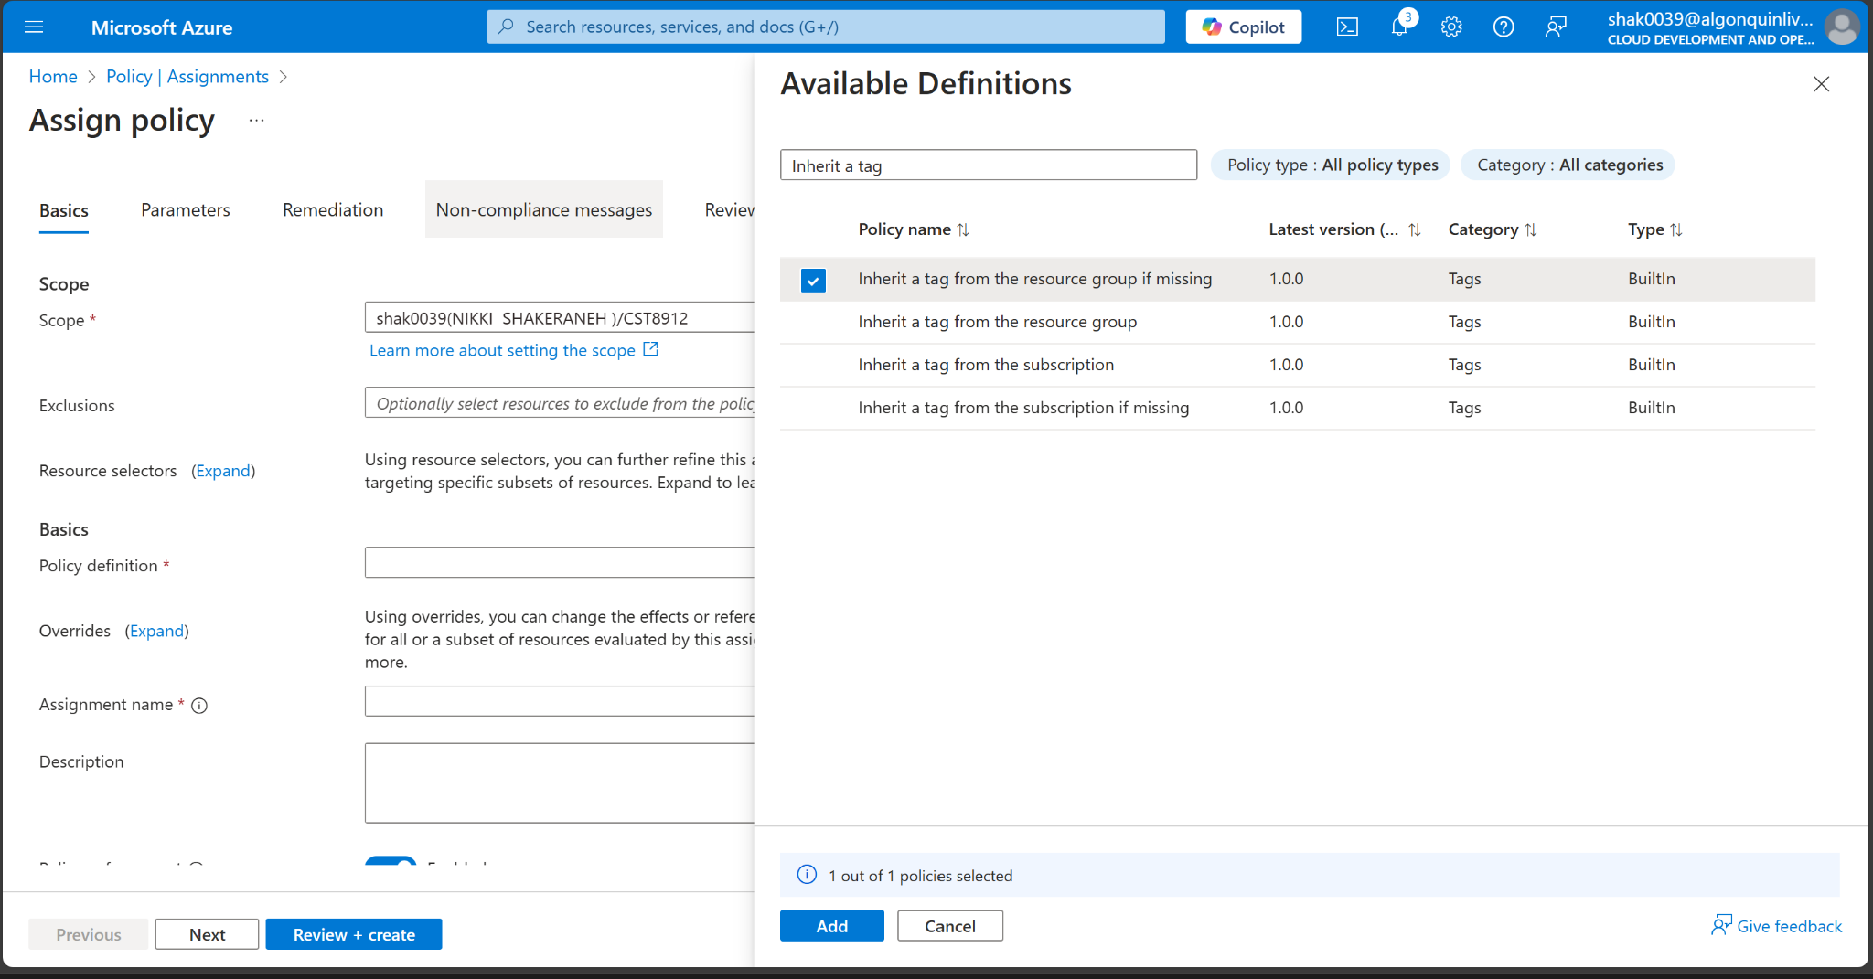

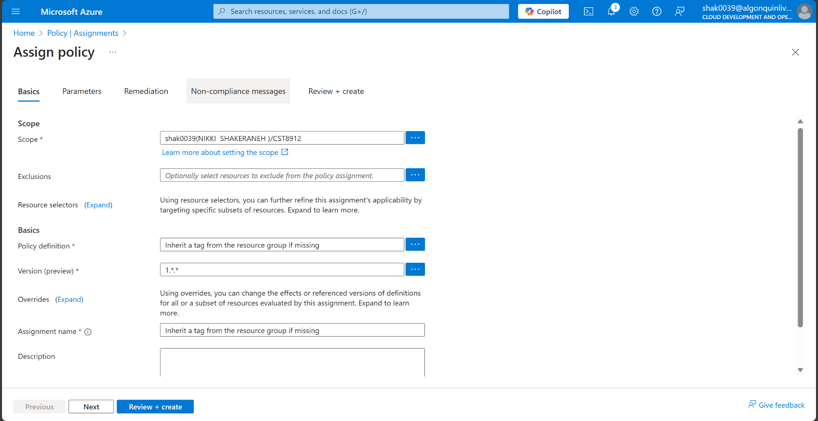

1. Select Add and then configure the remaining Basics properties of the assignment.

| Setting | Value |
| --- | --- |
| Assignment name | Inherit the Cost Center tag and its value 000 from the resource group if missing |
| Description | Inherit the Cost Center tag and its value 000 from the resource group if missing |
| Policy enforcement | Enabled |

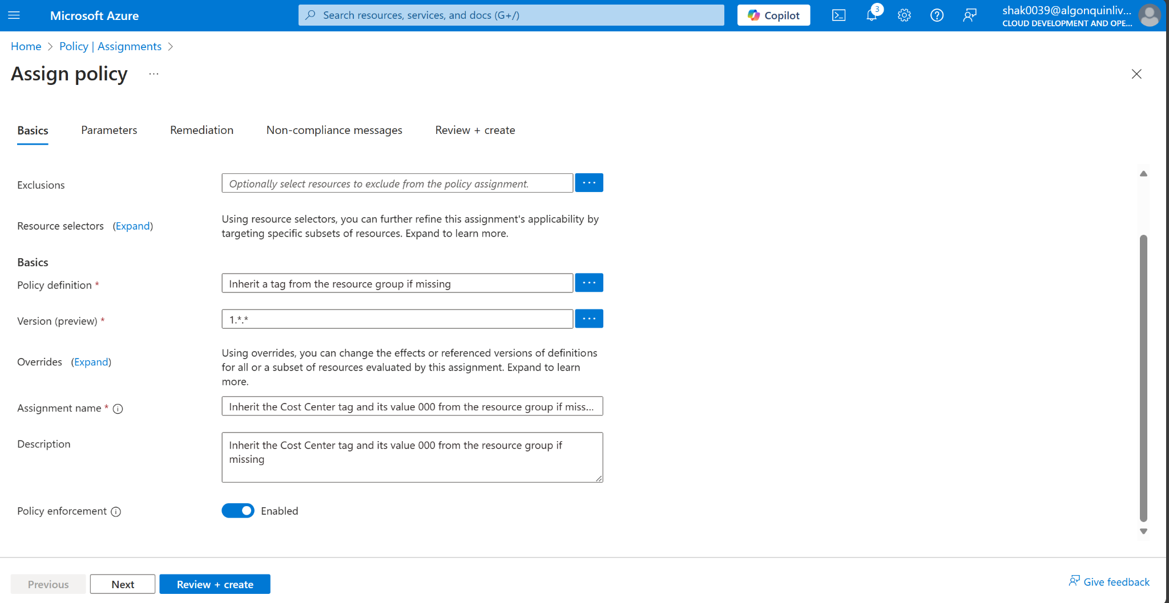

1. Click Next twice and set Parameters to the following values:

| Setting | Value |
| --- | --- |
| Tag Name | Cost Center |

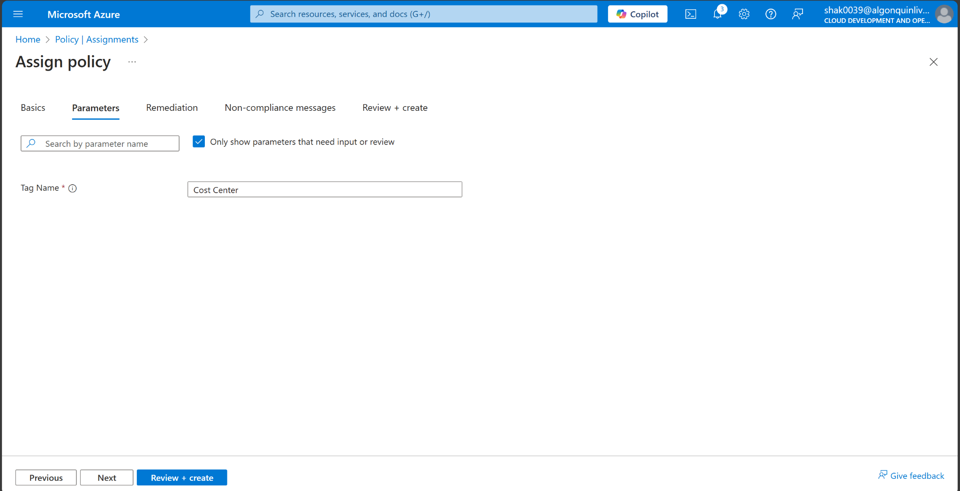

1. Click Next and, on the Remediation tab, configure the following settings (leave others with their defaults):

| Setting | Value |
| --- | --- |
| Create a remediation task | enabled |
| Policy to remediate | Inherit a tag from the resource group if missing |

1. Screenshot of the policy remediation page.

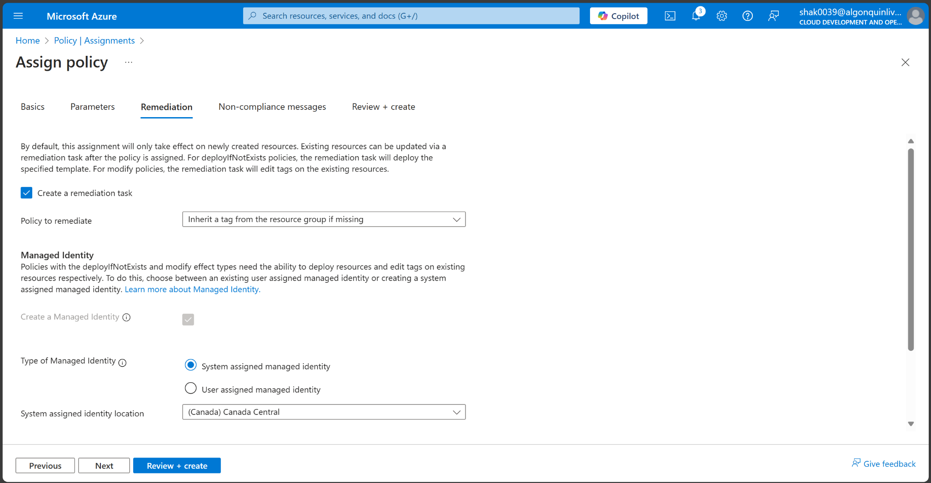

1. Click Review + Create and then click Create.

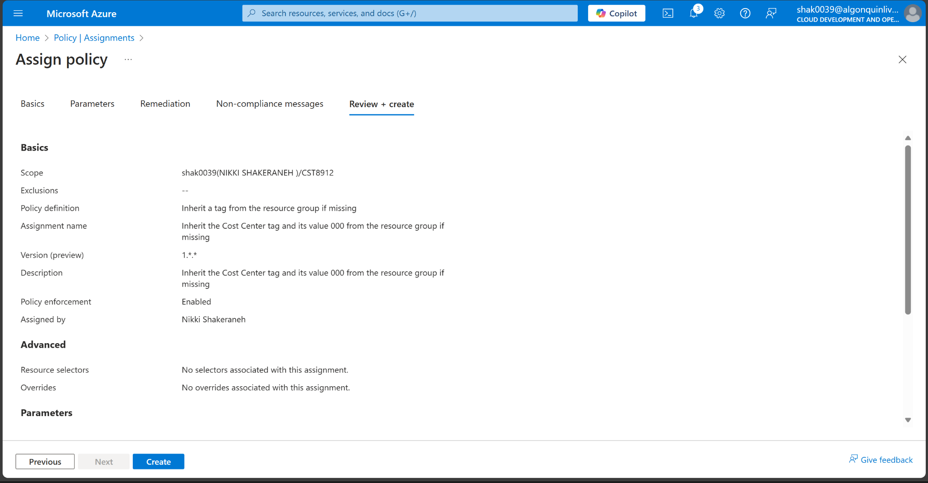

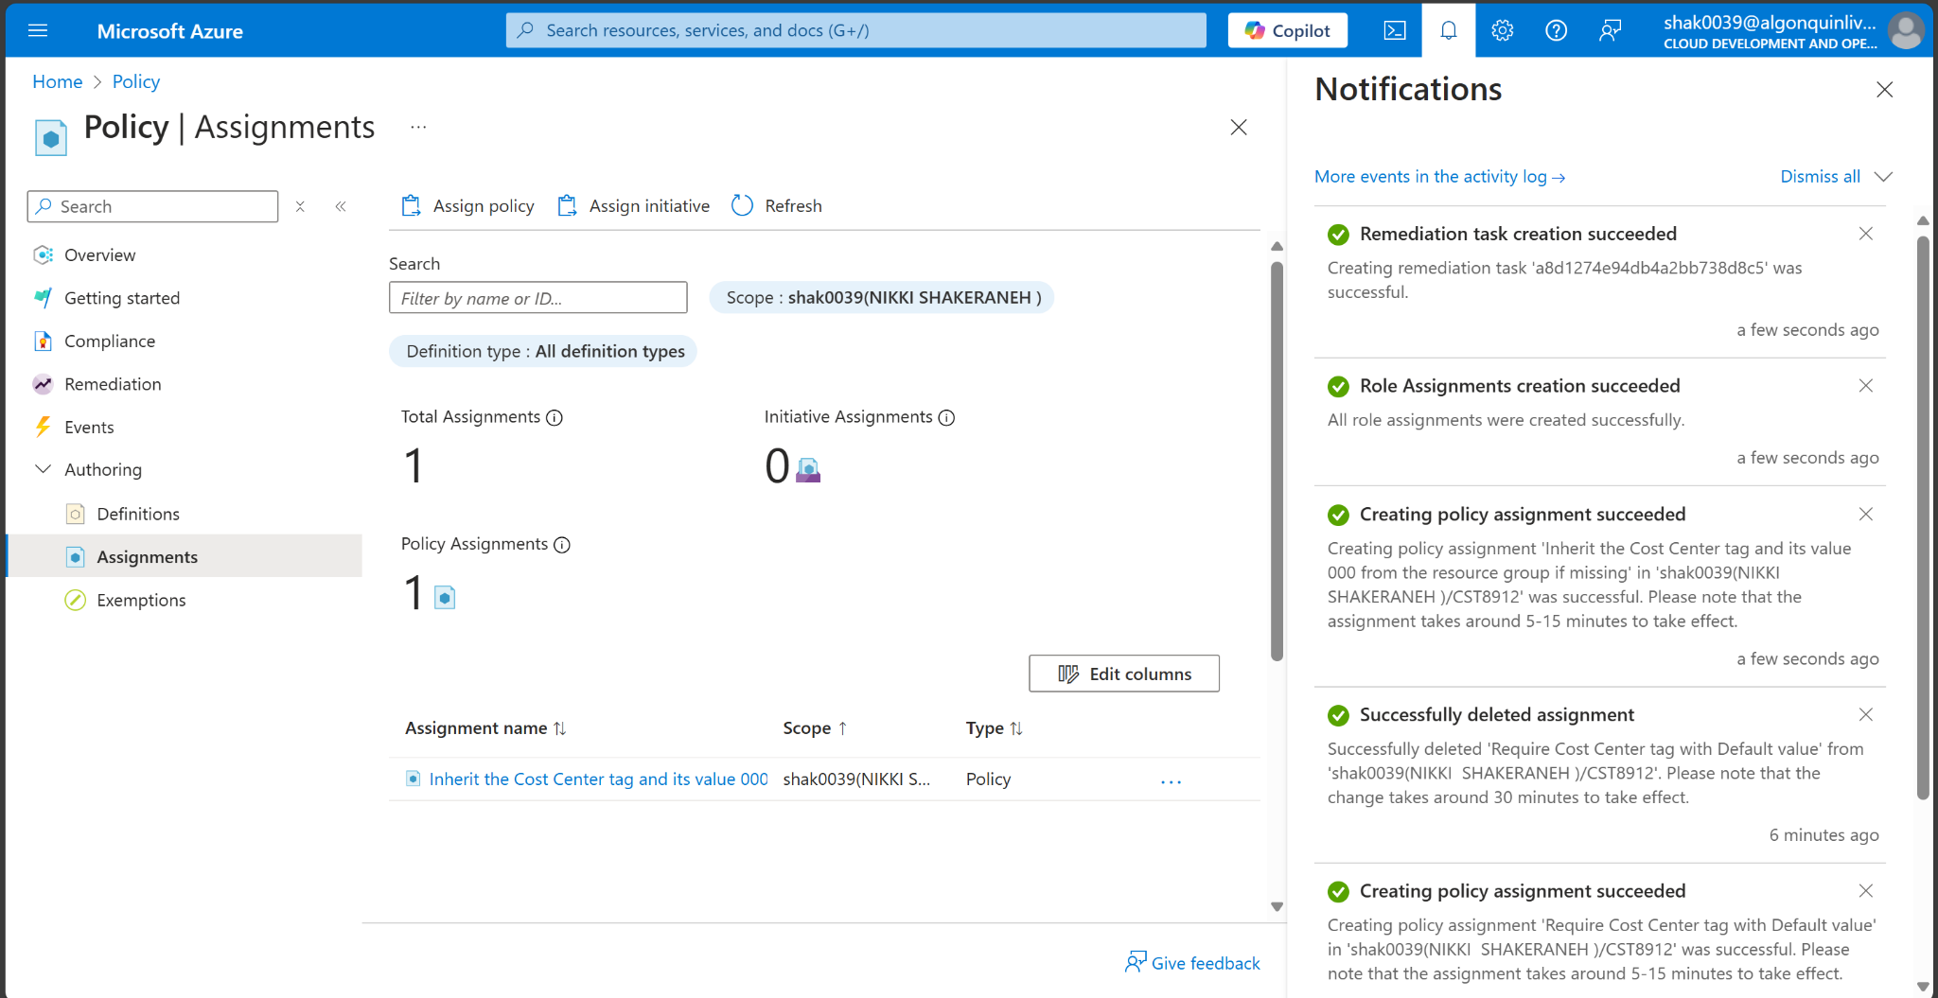

Note: To verify that the new policy assignment is in effect, you will create another Azure storage account in the same resource group without explicitly adding the required tag.

Note: It might take between 5 and 10 minutes for the policy to take effect.

Search for and select Storage Account, and click + Create.

1. On the Basics tab of the Create storage account blade, verify that you are using the Resource Group that the Policy was applied to and specify the following settings (leave others with their defaults) and click Review:

| Setting | Value |
| --- | --- |
| Storage account name | any globally unique combination of between 3 and 24 lower case letters and digits, starting with a letter |

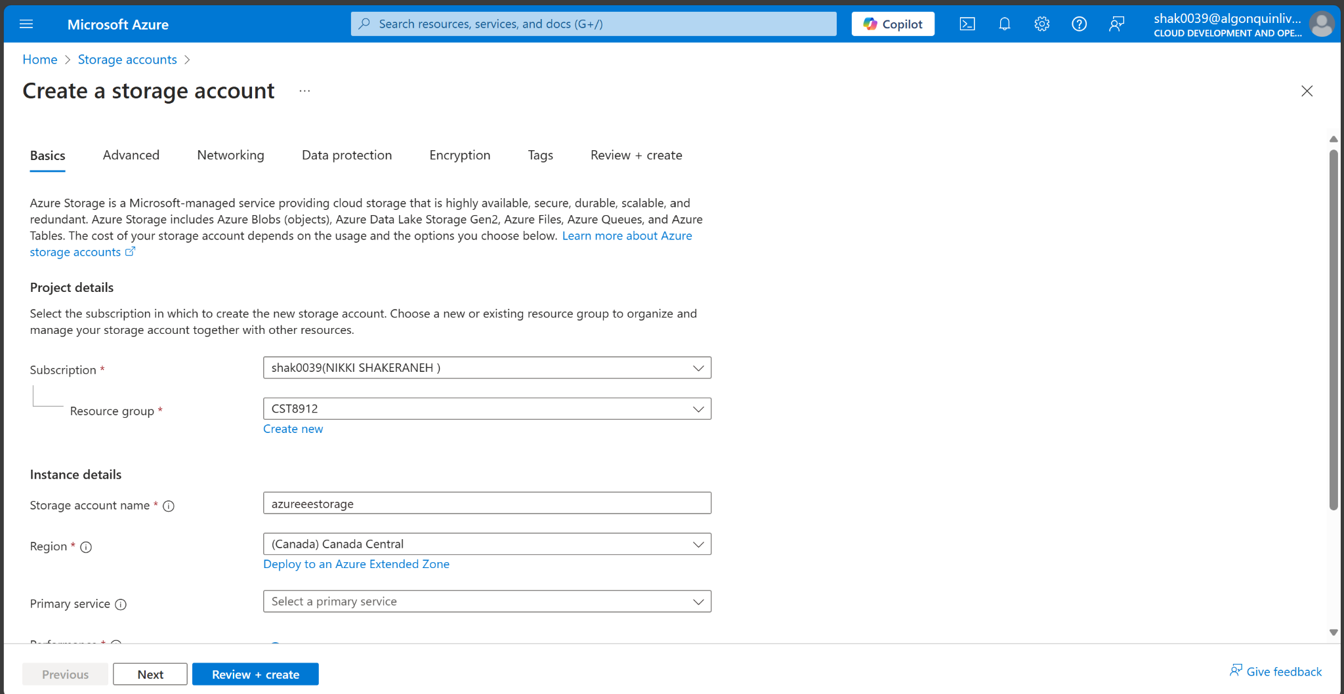

1. Verify that this time the validation passed and click Create.

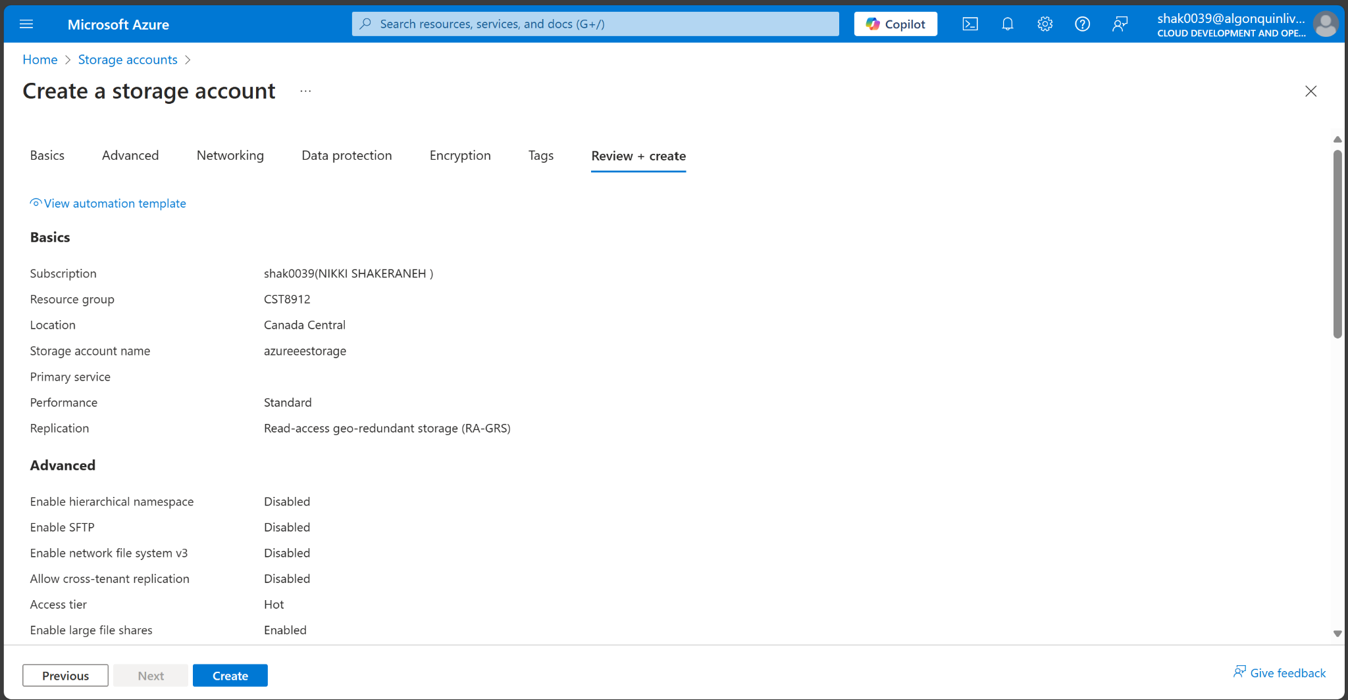

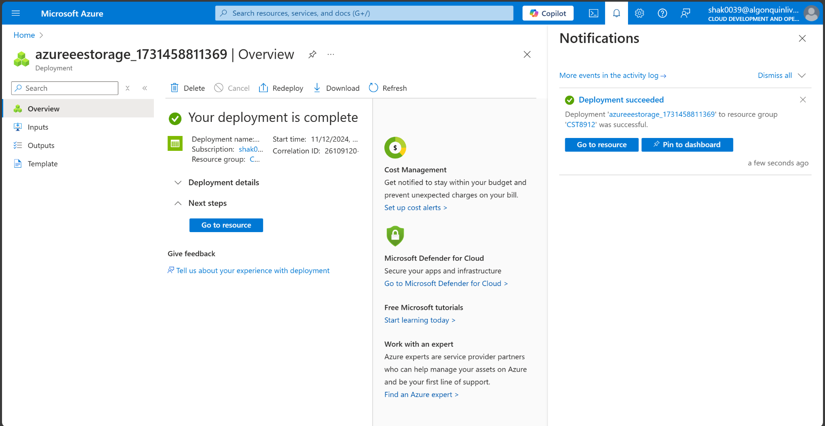

1. Once the new storage account is provisioned, click Go to resource.

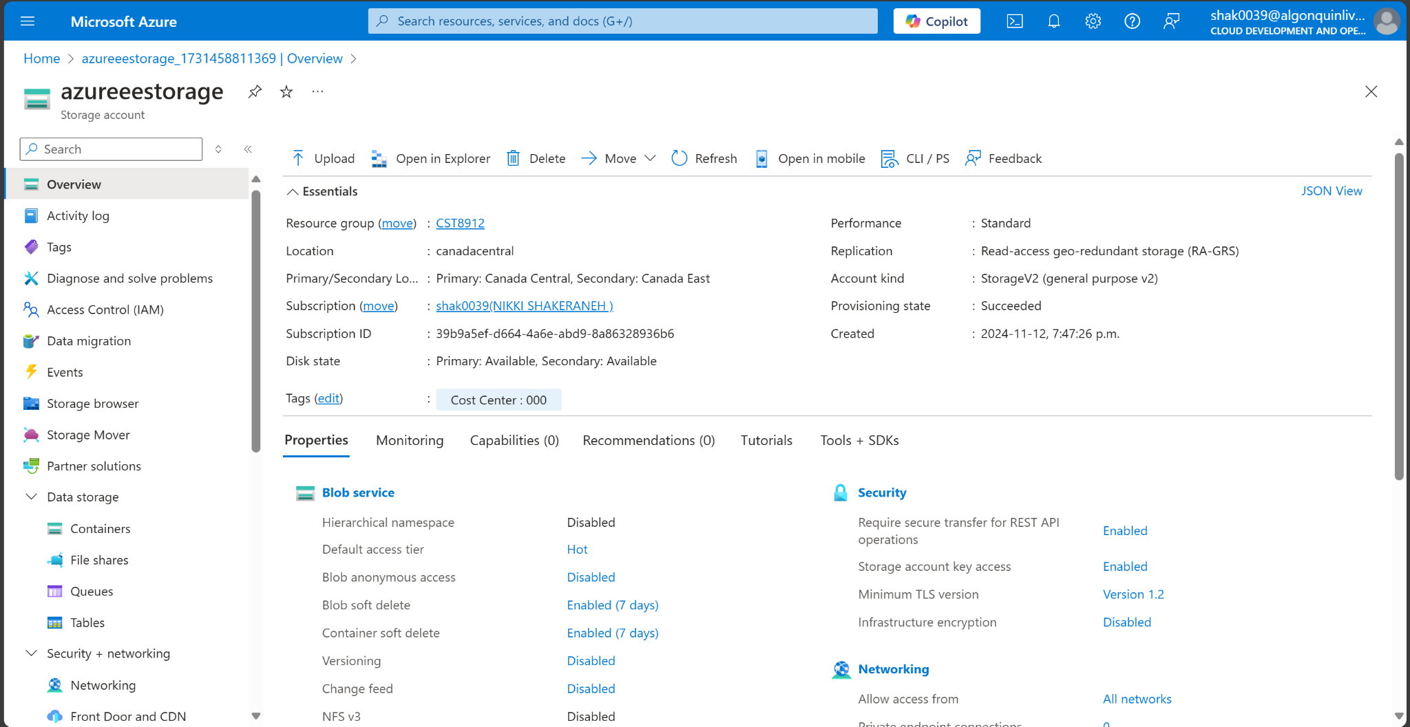

1. On the Tags blade, note that the tag Cost Center with the value 000 has been automatically assigned to the resource.

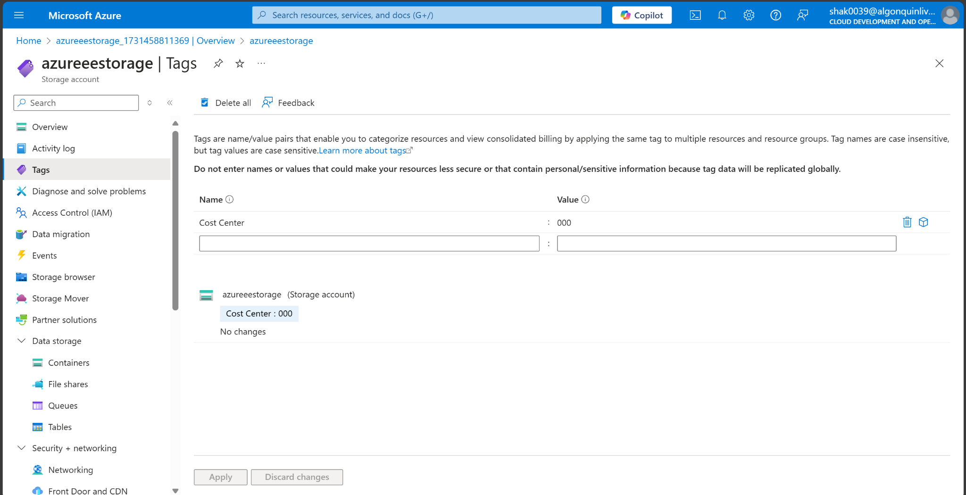

**Task 4**: Configure and test resource locks

1. Search for and select your resource group.

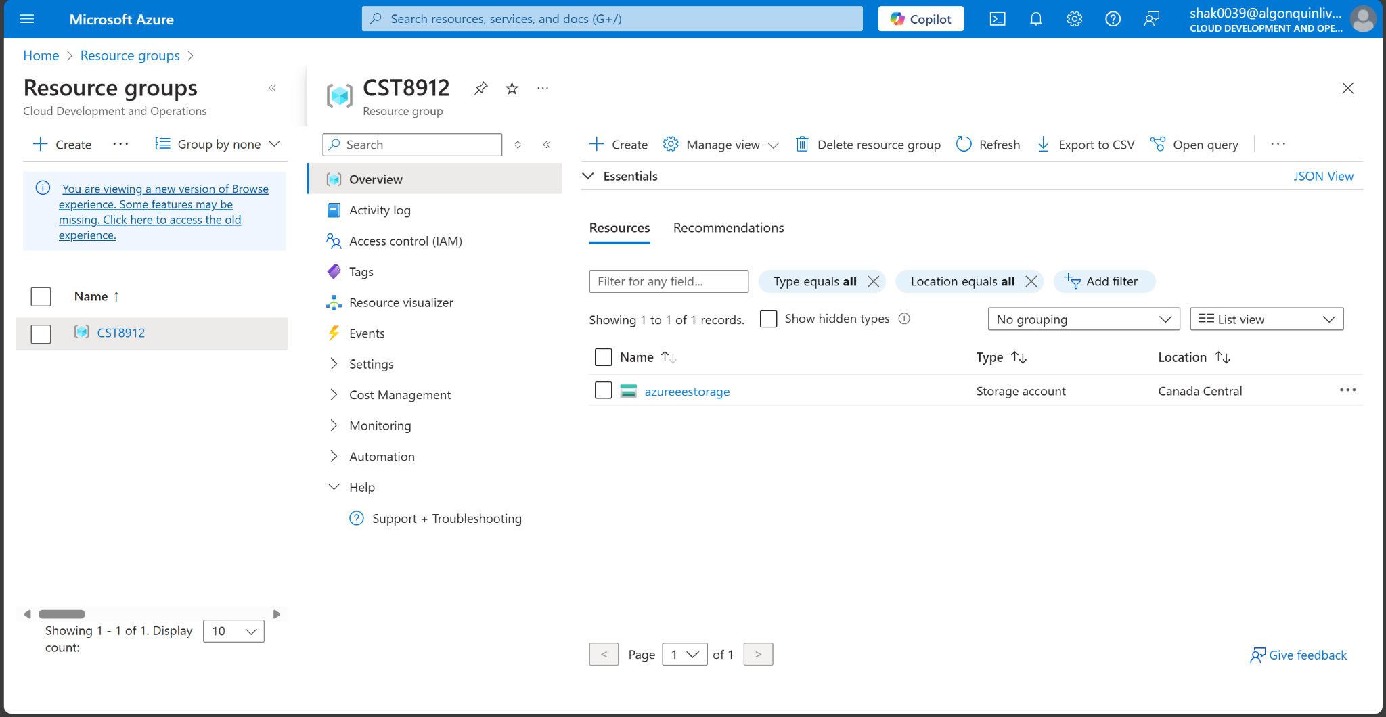

1. In the Settings blade, select Locks.

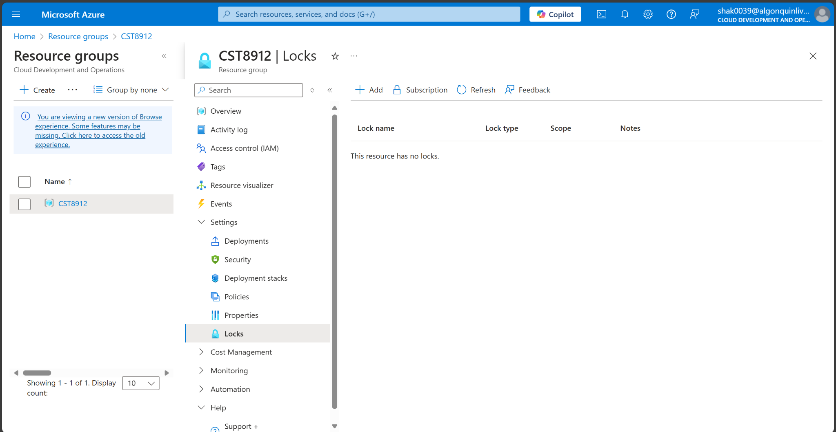

1. Select Add and complete the resource lock information. When finished select Ok.

| Setting | Value |
| --- | --- |
| Lock name | rg-lock |
| Lock type | delete (notice the selection for read-only) |

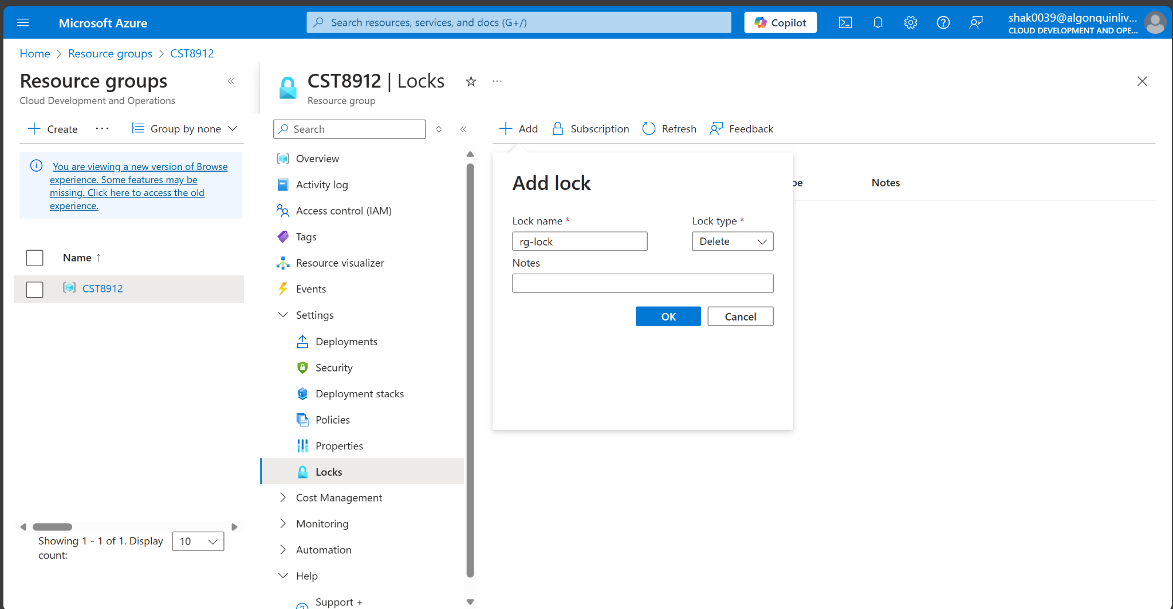

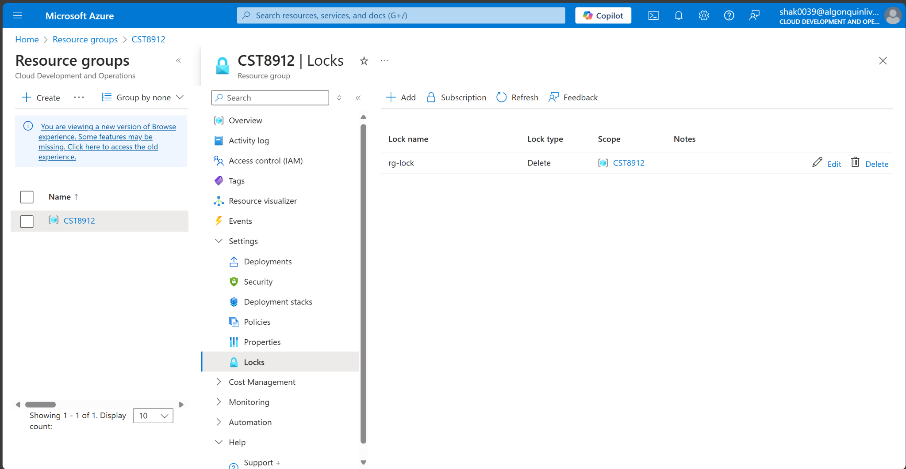

1. Navigate to the resource group Overview blade, and select Delete resource group.
2. In the Enter resource group name to confirm deletion textbox provide the resource group name, cst8912. Notice you can copy and paste the resource group name.

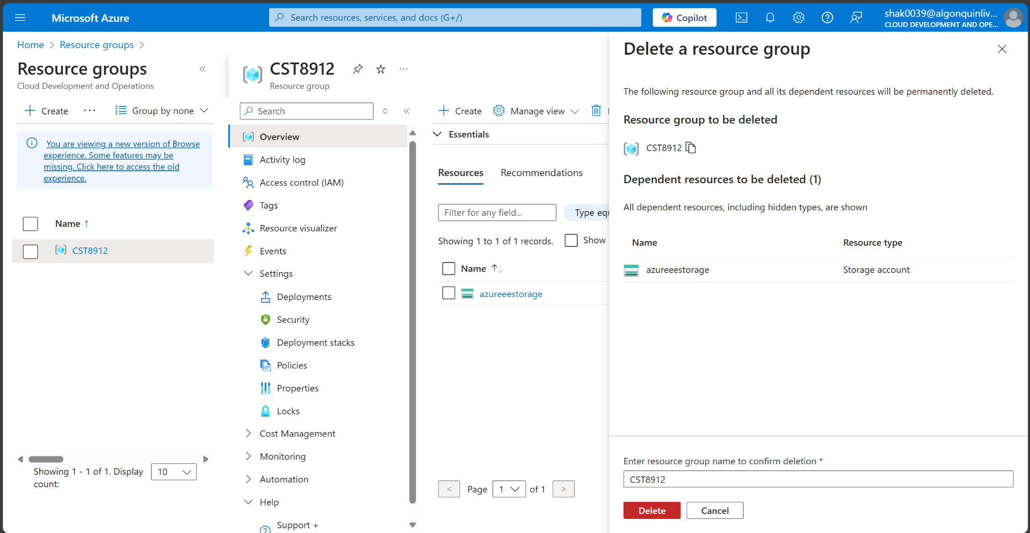

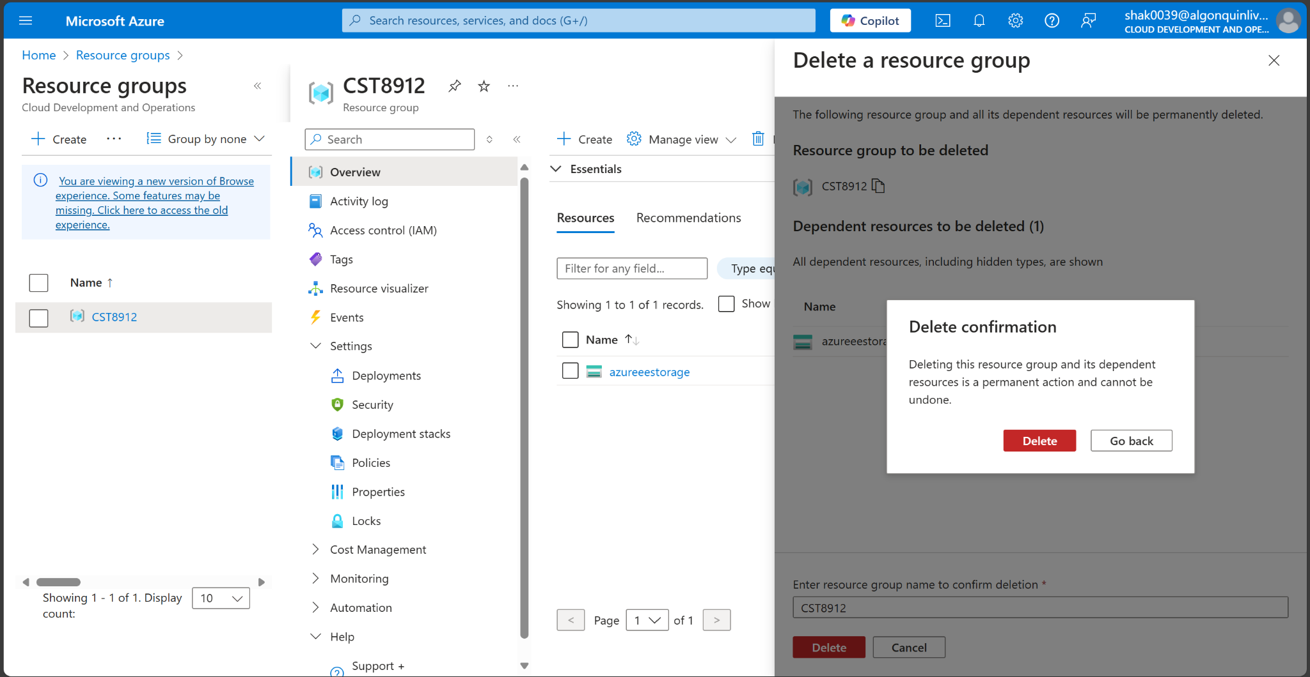

1. Notice the warning: Deleting this resource group and its dependent resources is a permanent action and cannot be undone. Select Delete.
2. You should receive a notification denying the deletion.

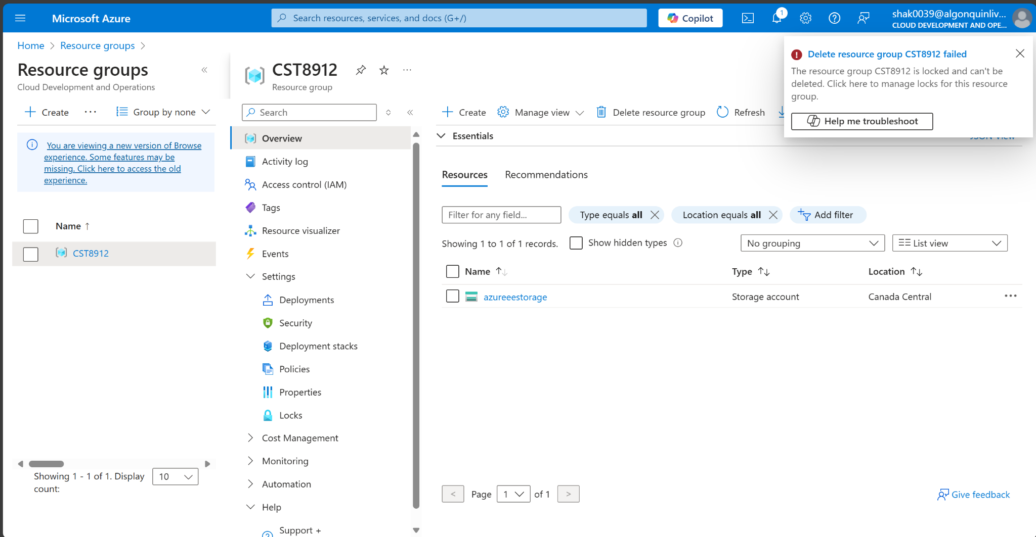

**Task 5: Clean up the resources**

1. In the portal, search for and select Policy.

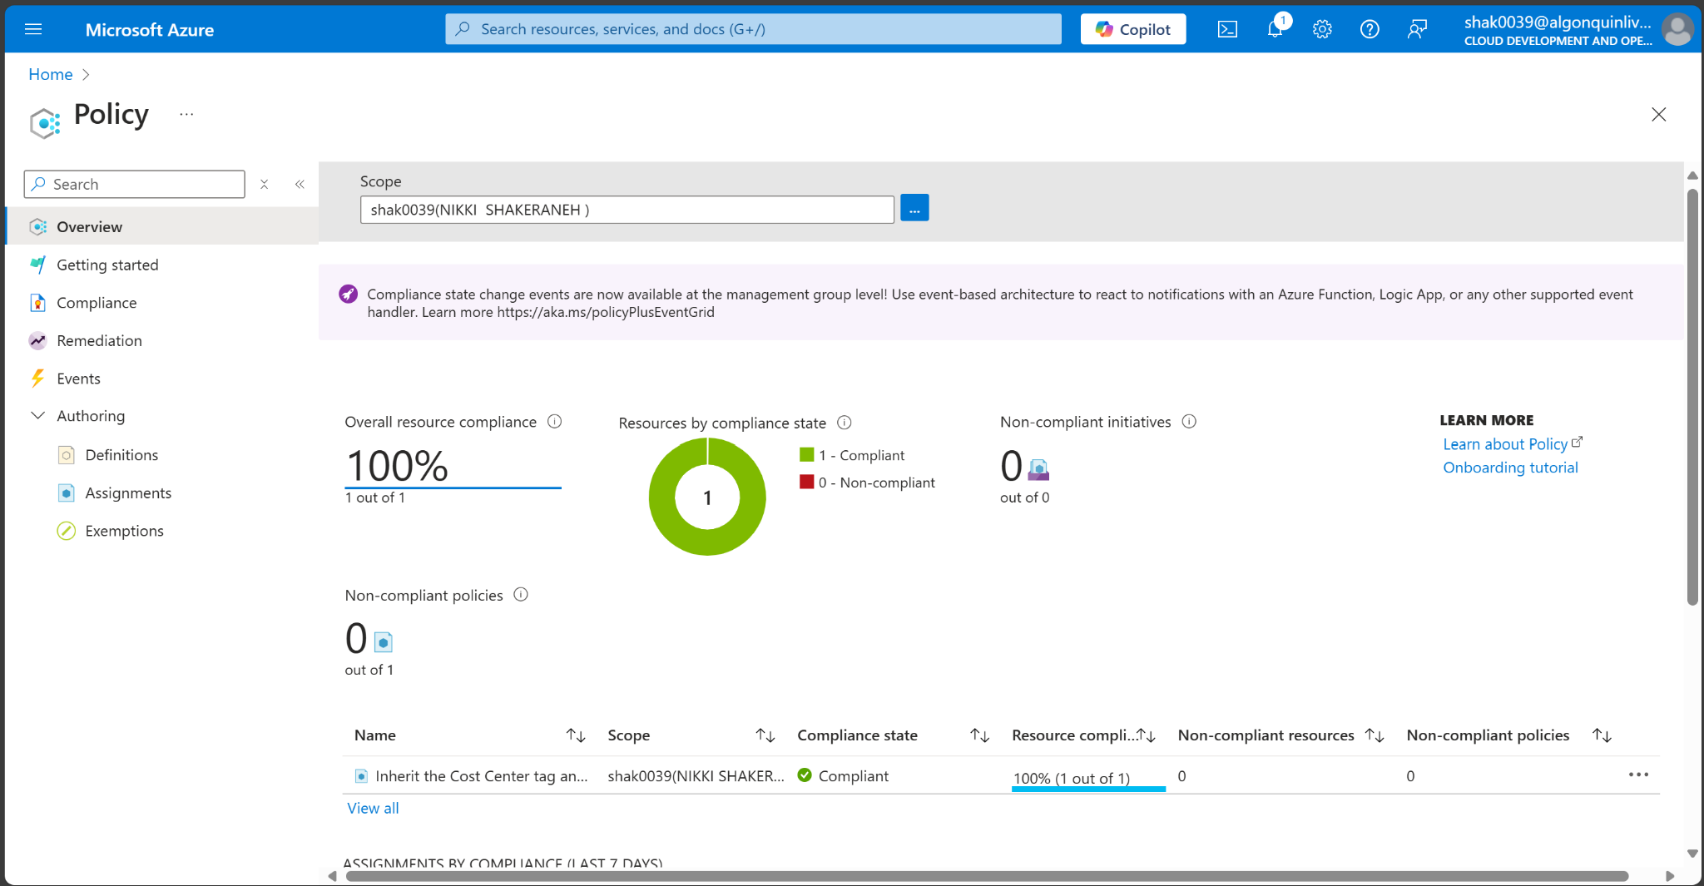

1. In the Authoring section, click Assignments, click the ellipsis icon to the right of the assignment you created in the previous task and click Delete assignment.

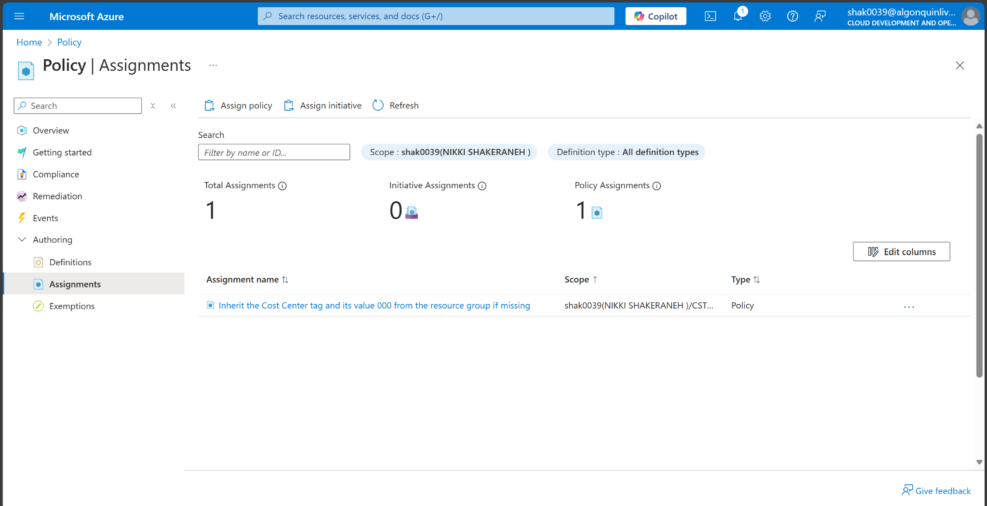

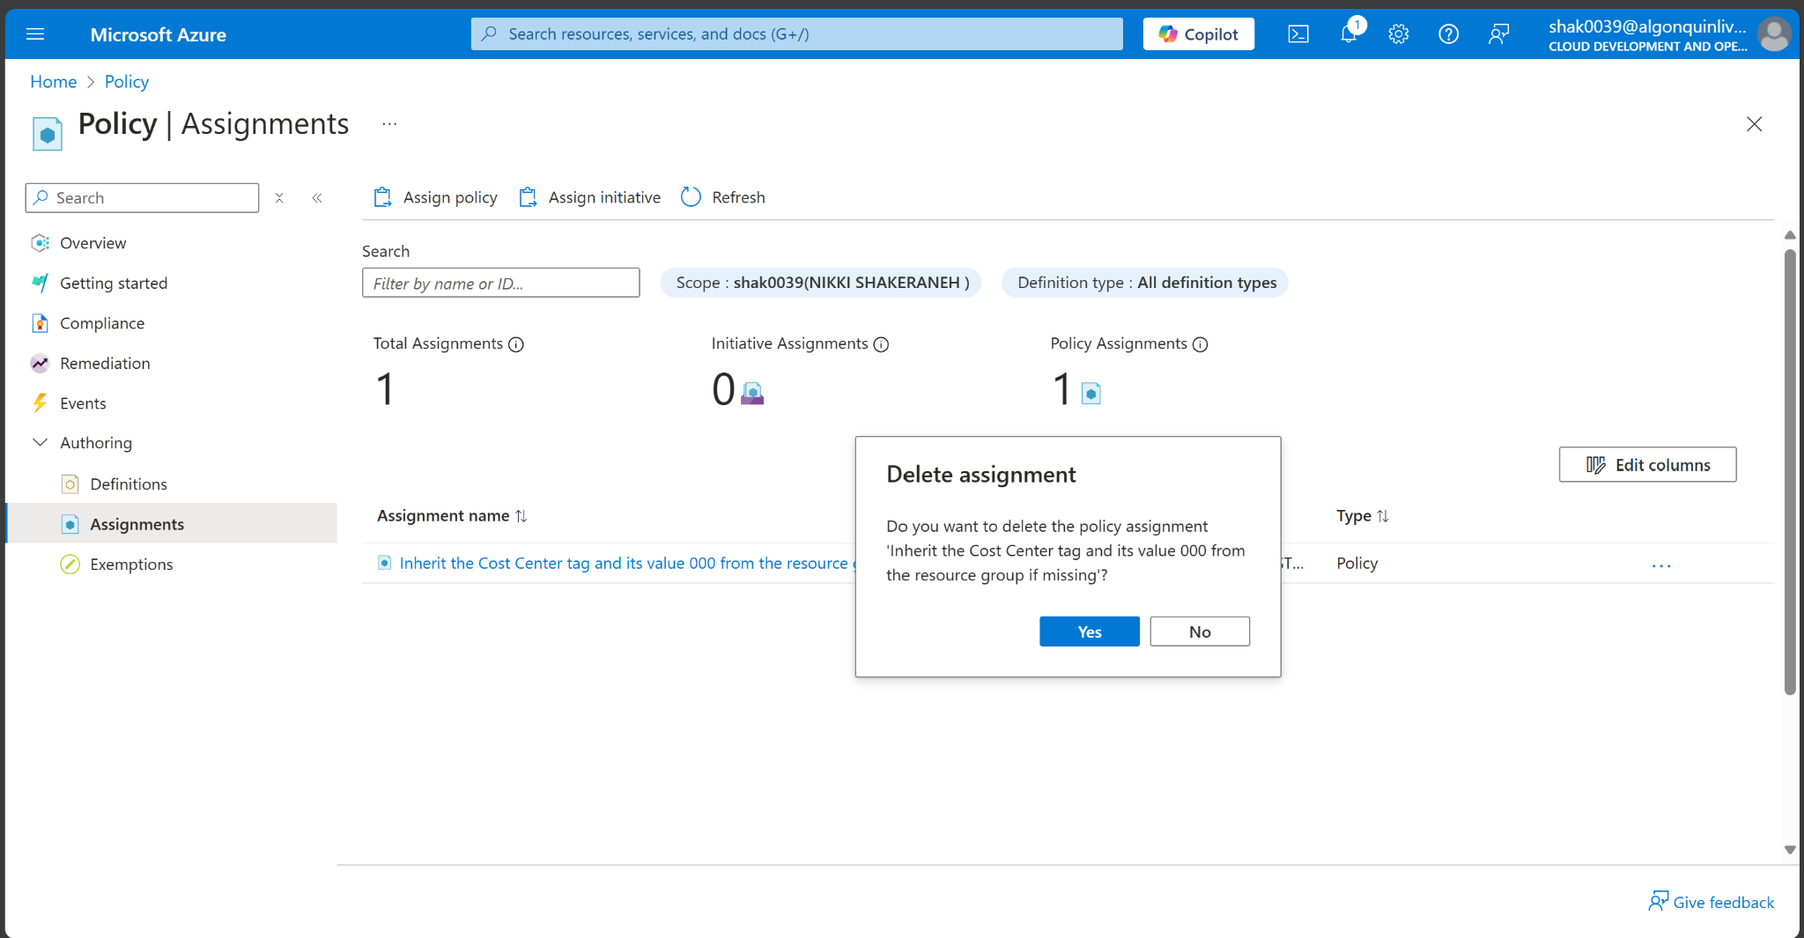

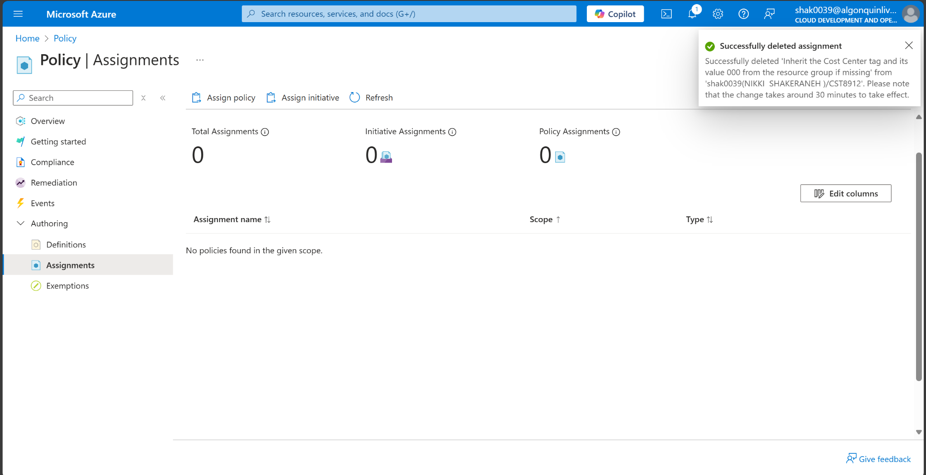

1. In the portal, search for and select Storage accounts.

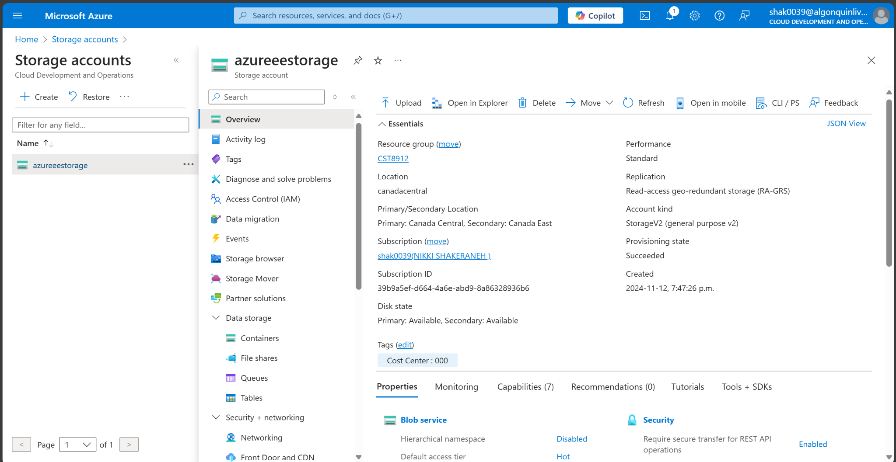

1. In the list of storage accounts, select the resource group corresponding to the storage account you created in the last task of this lab. Select Tags and click Delete (Trash can to the right) to the Role:Infra tag and press Apply.

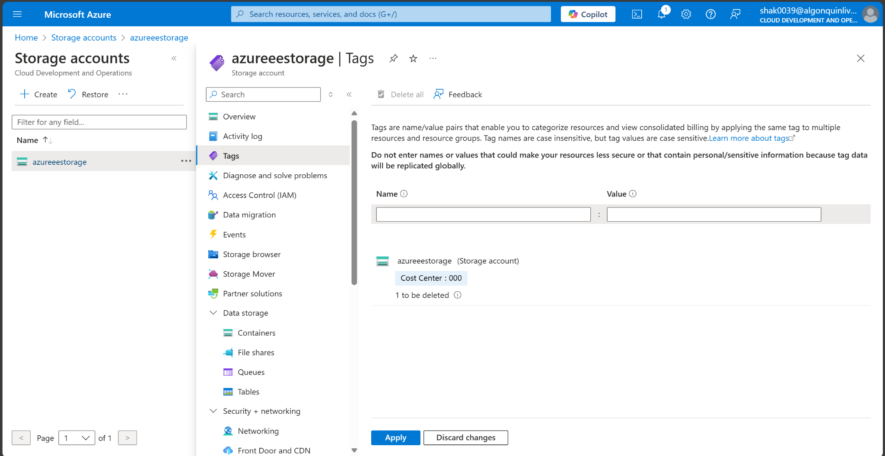

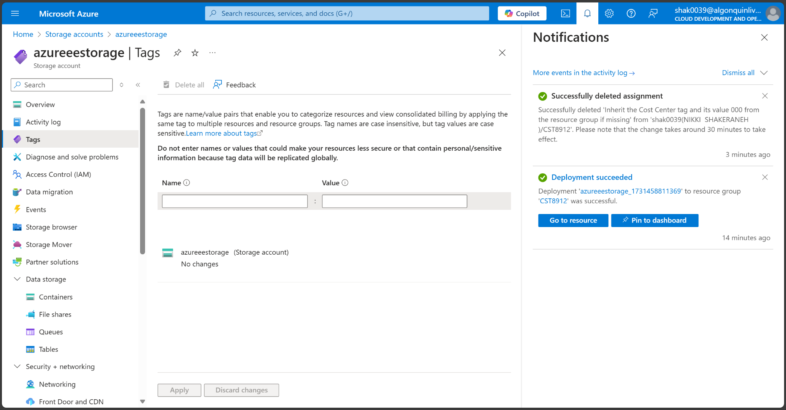

1. Click Overview and click Delete on the top of the storage account blade. When prompted for the confirmation, in the Delete storage account blade, type the name of the storage account to confirm and click Delete.

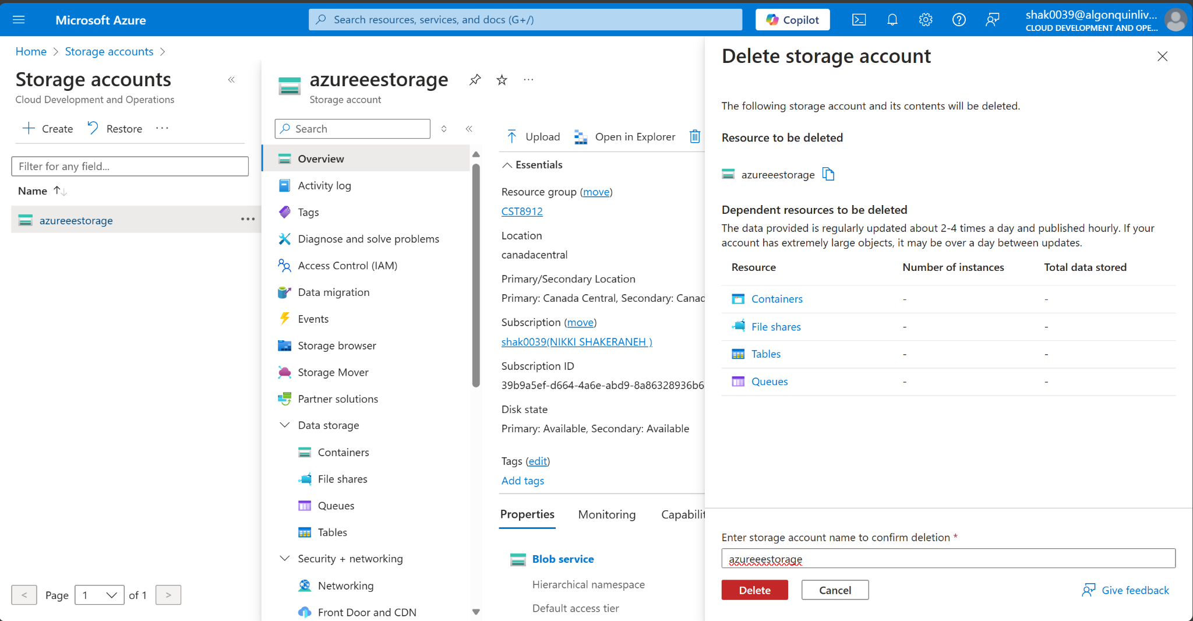

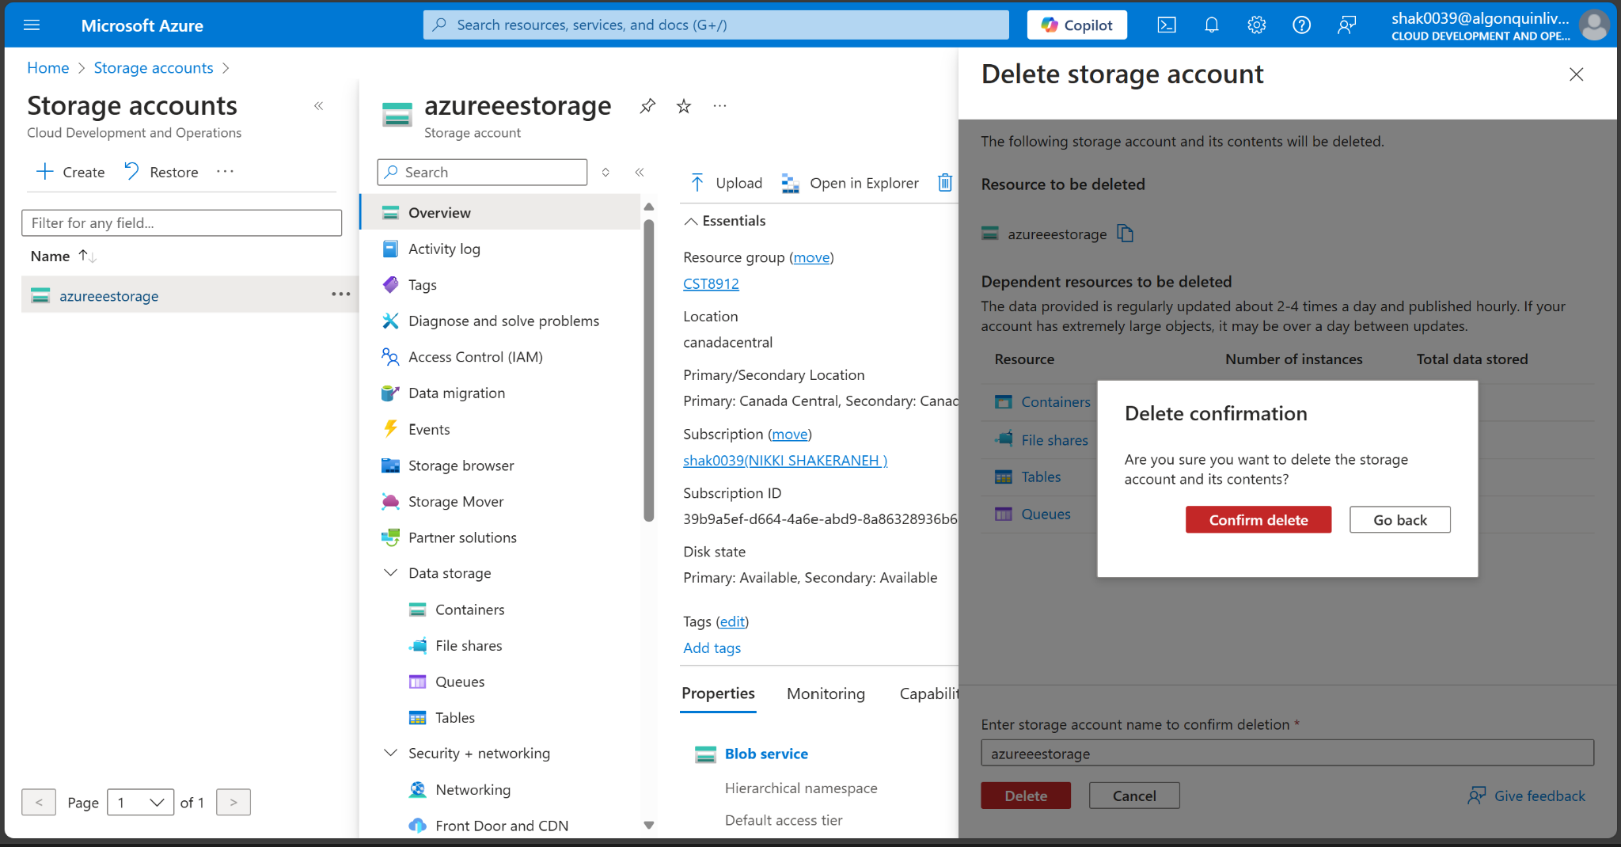

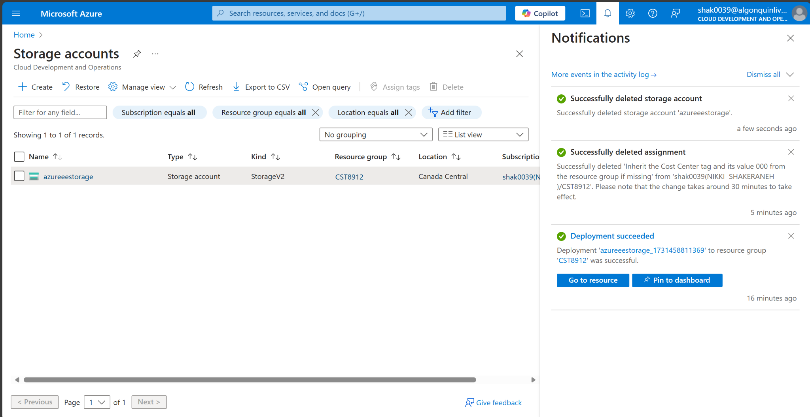

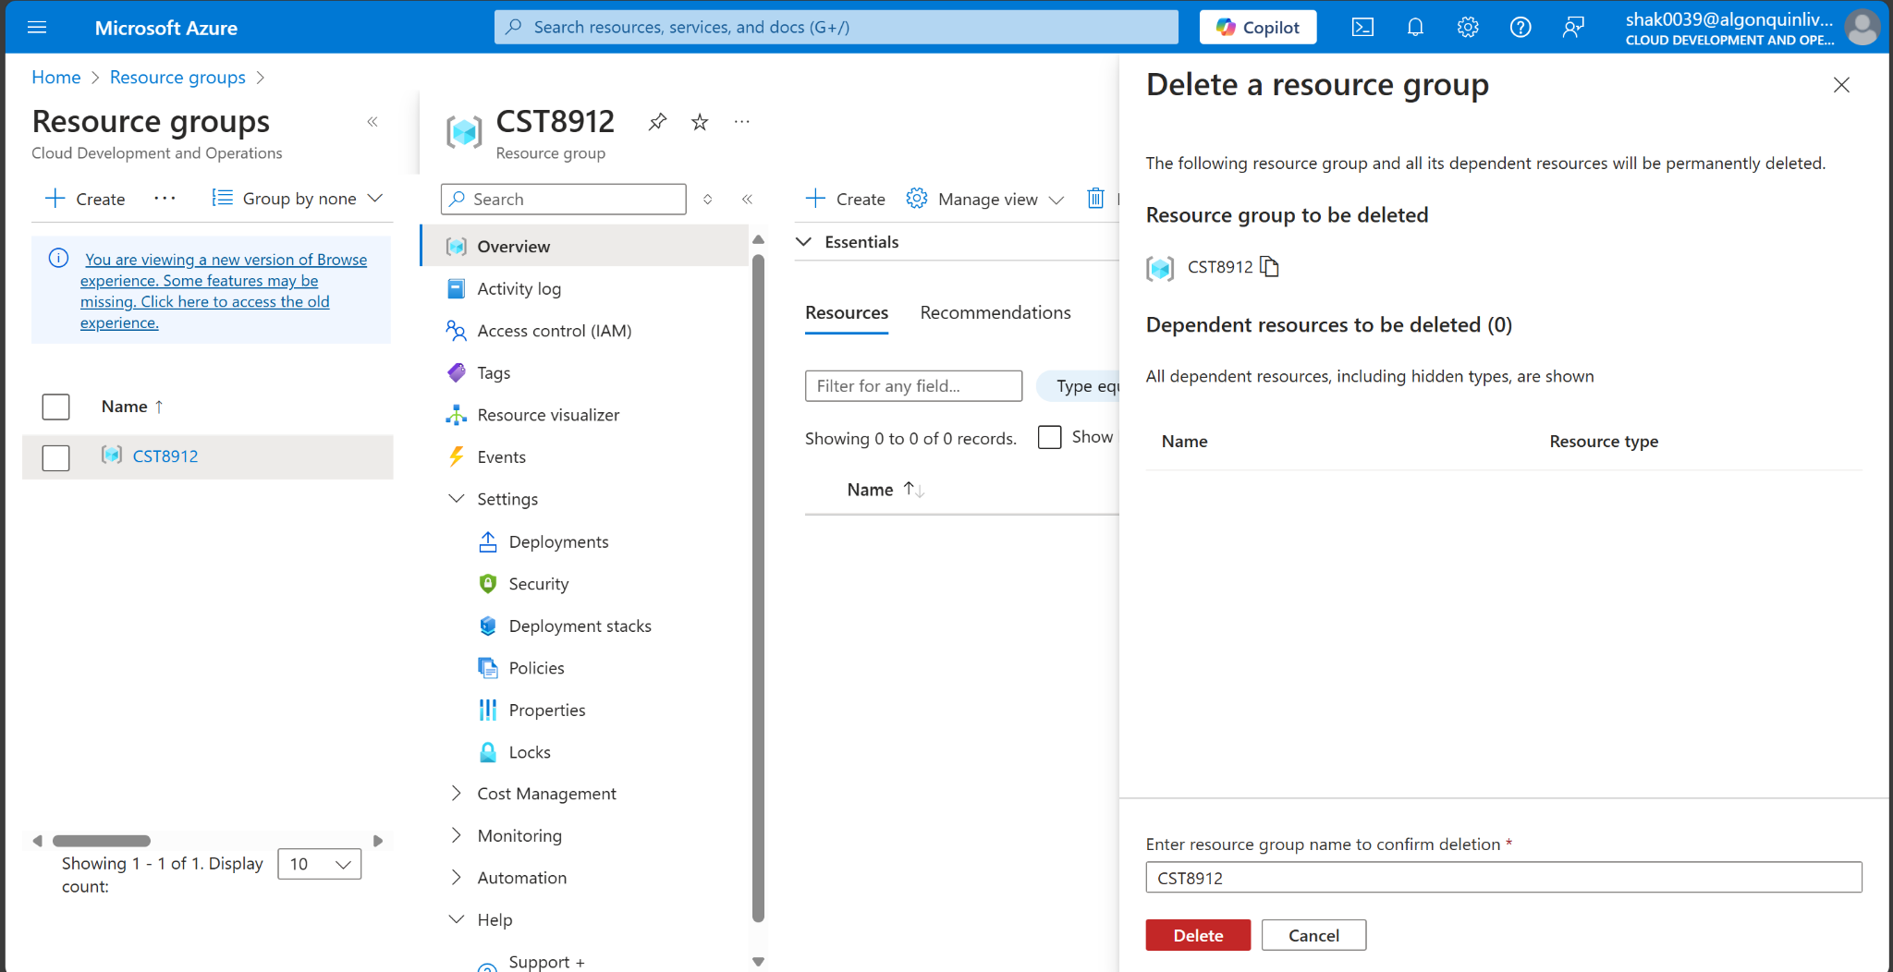

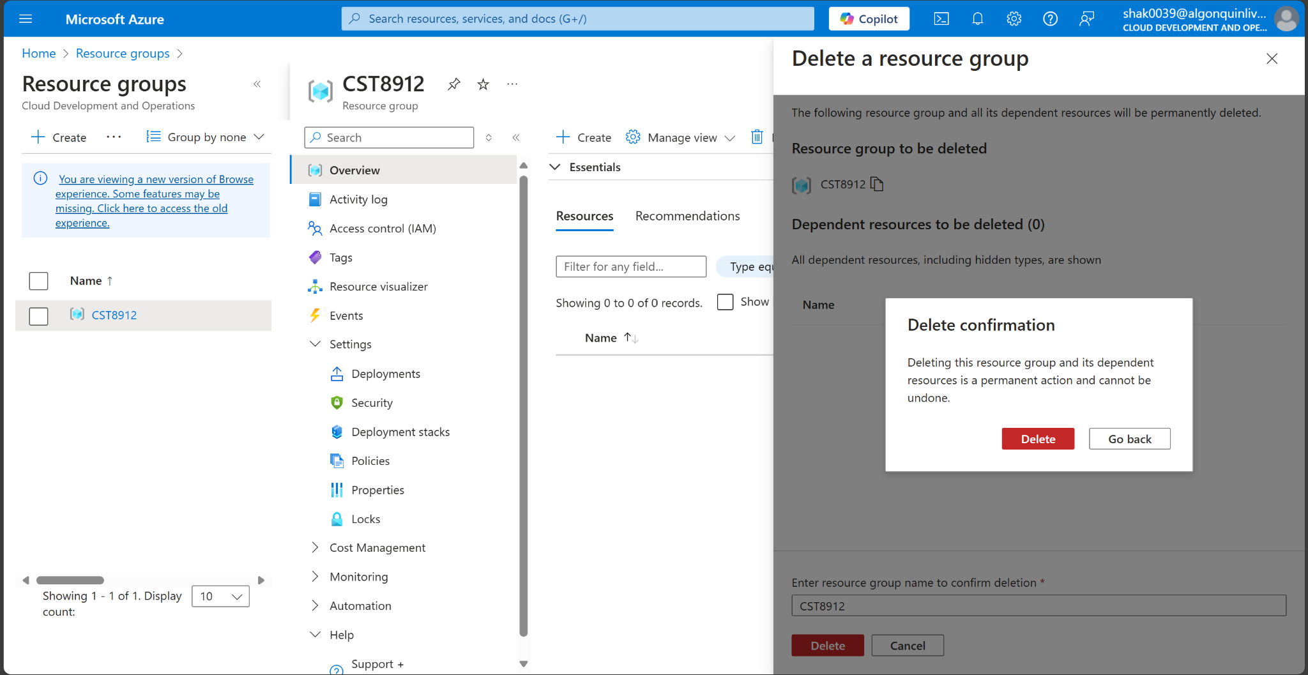

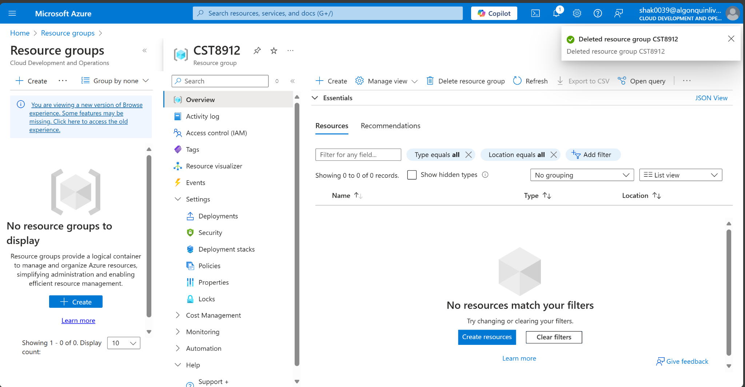

**Lab Report**

In this lab, I was able to get some practice in implementing tagging, policy enforcement, and resource locks in Azure to ensure compliance with the regulatory requirements. First, I learned to set up a foundational governance framework, and also to enforce a rule that requires all resources in this group to have the "Cost Center" tag. Next, I learned about the tag inheritance policy that applies the "Cost Center" tag to any child resources automatically. This is important, because it ensures that the tagging is consistent throughout the resource group. I also applied a resource lock, which blocked deletion attempts, and it enhanced protection against accidental or unauthorized deletions. This lab was very helpful overall, because it demonstrated the importance of tagging for cost management and automated policy enforcement for regulatory compliance. By combining these tools, I gained a better understanding of the shared responsibility model for cloud security, as well as how to ensure that I am achieving data privacy, data protection, and cybersecurity standards.